Guidance Note

Topic: | ASB Deliberate Fires: Reinforcement
Risk Factor(s): | ASB, Peer Pressure
Guidance Notes: | This session is designed to be delivered during a 10-15 minute registration-type session or it could be expanded through more time for discussion and exploring the questions into a full tutorial sessions.

Slide Guidance
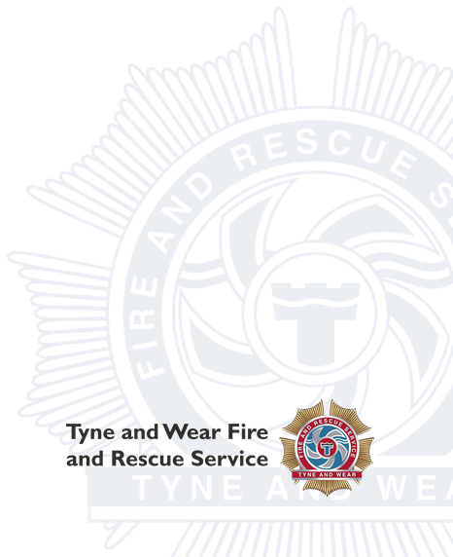
Slide | Purpose | Teacher Notes
Slide 1: Introduction | Introduce the session and remind learners of the session with TWFRS | - Explain that today's session will reinforce the key messages
Slide 2: Recap | Recap what the learners learnt during the session with TWFRS | Allow 1-minute paired discussion and then take quick responses form some learners to check understanding.  - What is arson? – Setting a deliberate fire with intent to cause damage, includes setting rubbish, bins and grass on fire  - Why are deliberate fires dangerous? Spread easily causing more damage, pulls fire service away from other emergencies  - Consequences – burns, death, criminal record, fine, prison, unable to do certain careers, unable to get rental properties
Slide 3: Reflection | Encourage critical thinking about how to deal with peer pressure | - Allow learners time to discuss  - Encourage practical strategies such as realistic excuses (need the toilet, curfew, going in for my tea etc)
Slide 4: Scenario Activity | Develop decision-making and risk identification skills | - Facilitate discussion rather than looking for "correct" answers  - Encourage learners to:  - identify risks  - consider consequences  - suggest exit strategies  - think about peer pressure
Slide 5 & 6: True or False? | Reinforcing dangers and strategies previously learnt | - Quick fire – ask learners to put one hand up for true and 2 hands up for false.  Further notes for discussion if time allows:  - Starting a fire as a prank can still be a crime - True – still classed as arson  - If nobody gets hurt, there are no consequences for starting a fire - False – still arson so could get criminal record, as well as preventing firefighters going to other emergencies and causing damage  - Firefighters attending deliberate fires may be delayed from other emergencies - True – cant be in two places at once, everything they attend is emergency so even if it’s a deliberate fire have to deal with that same as other incidents  - Deliberate fires only affect the person who starts them - False – ripple effect – affects emergency services, members of the public (2 places at once)  - Walking away is a positive choice- True – keeps you safe and out of trouble  - A small fire can quickly spread and become dangerous – True – lots of different accelerants you wont be aware of  - Recording a deliberate fire for social media isn’t as bad as starting the fire – False – you are encouraging the behaviour and could be arrested for joint enterprise, you can still be held responsible for what happens, even if you didn't do it yourself  - Reporting a deliberate fire is the right thing to do - True – if you don’t it could get bigger and hurt others  - Young people cannot be held responsible for deliberate fires – False – you can get a criminal record from 10, and arson stays on your record for life  - One good decision can stop a small problem becoming a major incident - True – if you don’t set the fire, you are stopping the ripple effect and consequences before it starts
Slide 7 : Final Thoughts | Recap on session | - Learners to reflect on one thing they’ll remember  - Learners to reflect on what they would do in a potentially unsafe situation
Slide 8 : Stop - Think - Choose - Act | Reinforce safe decision making | - Remind learners to consider:  - Is it safe?  - Is it legal?  - Could someone get hurt?  - Reinforce that walking away is a positive choice

