

Quarter 1 Performance Report (Year to Date)
01 April 2026 to 30th June 2026

2026/27

01 April 2026 to 30 June 2026

Our performance is managed and monitored robustly to enable us to identify issues and implement improvement action and identify success, promoting and sharing good practice across the Service and beyond. The Service’s vision and mission guides all our strategic planning, and we place our communities at the heart of everything we do.

Our Vision, Mission and Values
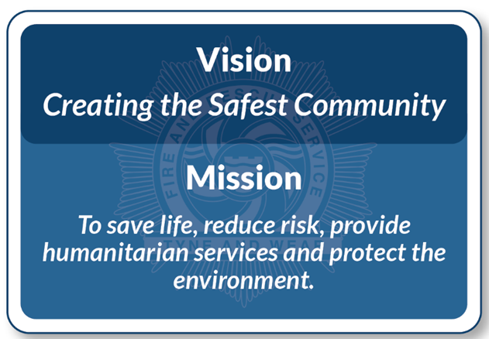
Our Goals
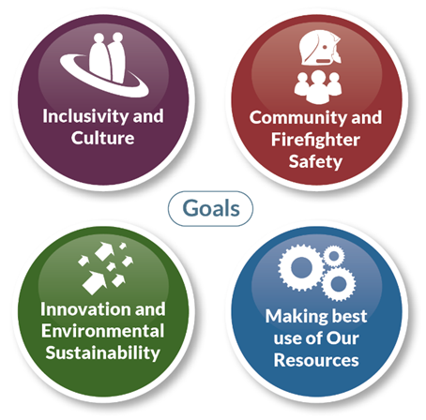
Progress towards achieving the goals set out within our strategy is monitored and regularly reported on through our Performance Reporting Process.
2026/27

01 April 2026 to 30 June 2026

Our Local indicators focus on incidents and fires attended by Tyne and Wear Fire and Rescue Service. These include fire related fatalities, casualties from those fires and response times to those fires, dwelling fires, false alarms and a number of other indicators.

The data contained in this report was ran on 04/08/2026.

Q1 Operational Performance highlights compared with Q1 2025/26:

- 4484 incidents attended, this is a decrease of 18% (972), (LI32).
- Injuries from all fires decreased by 33% (14) (LI05).
- Injuries from accidental dwelling fires decreased by 44% (4) (LI03).
- All 5 of the injuries from accidental dwelling fires were recorded as slight (LI03).
- Accidental dwelling fires decreased by 3% (4) (LI08).
- An alarm was present in 90% of accidental dwelling fires.
- In 69% of accidental dwelling fires the alarm activated.
- There was a 39% (827) decrease in deliberate fires (LI33).
- Non-domestic fires have decreased by 46% (26).
- False alarms in domestic premises (LI23) have increased by 4% (31) and false alarms in non-domestic premises have increased by 27% (63).
- Special Services have increased by 8% (68) from 834 in 2025/26 to 902 in 2026/27.
- 10 attacks on Firefighters, an increase of 25% (2).
- A total of 7208 Home Safety Engagements were carried out, a decrease of 3% (241).
- The overall average response time was 6 minutes 28 seconds, this is 10 seconds slower than in Q1 2025/26.
- Pumping appliances were available 94% of the time during Q1 2026/27 whereas in Q1 2025/2026 pumping appliances were available 97% of the time.
- 217 Fire Safety Audits carried out, 14% of yearly target.
- 8 Prohibition Notices were served in Q1 2026/27.

910

24

1,336
1,238

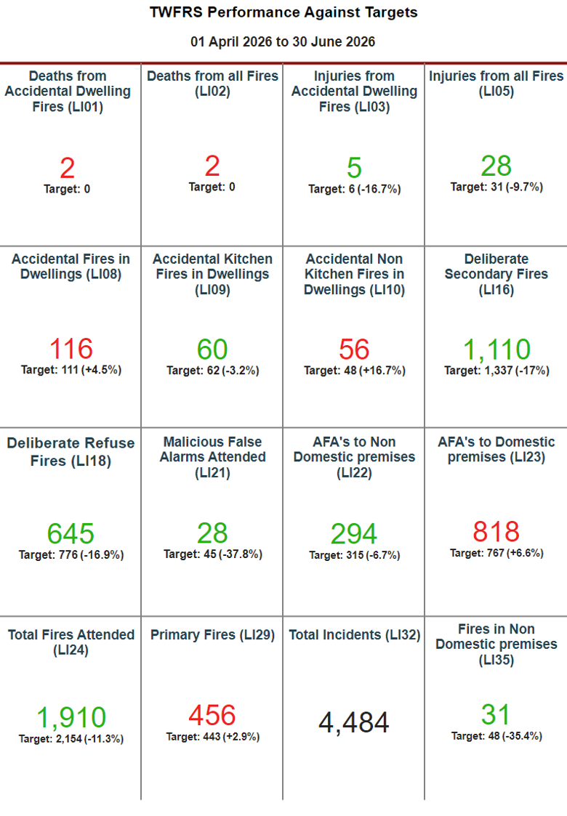
456
818
116

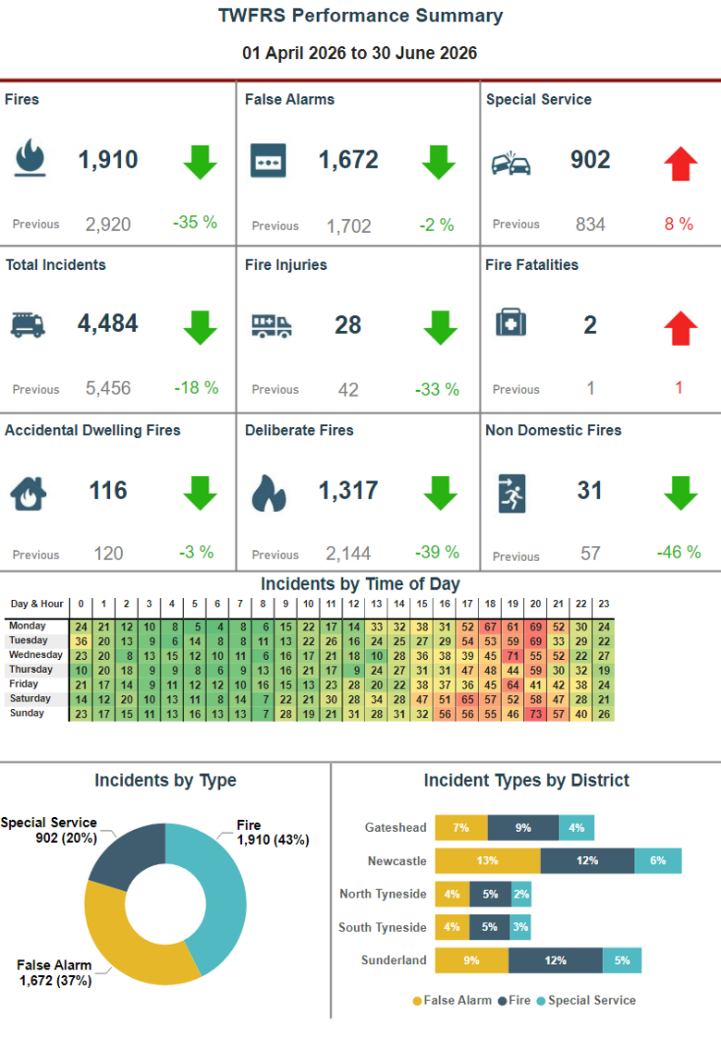

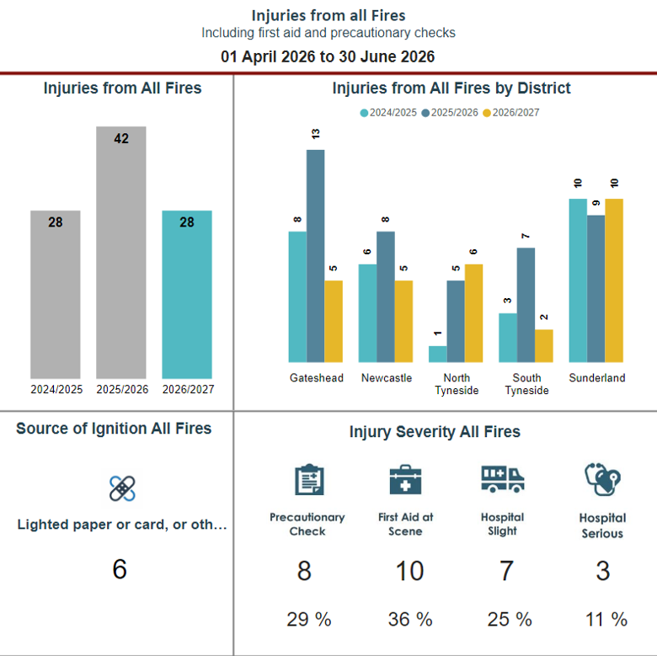

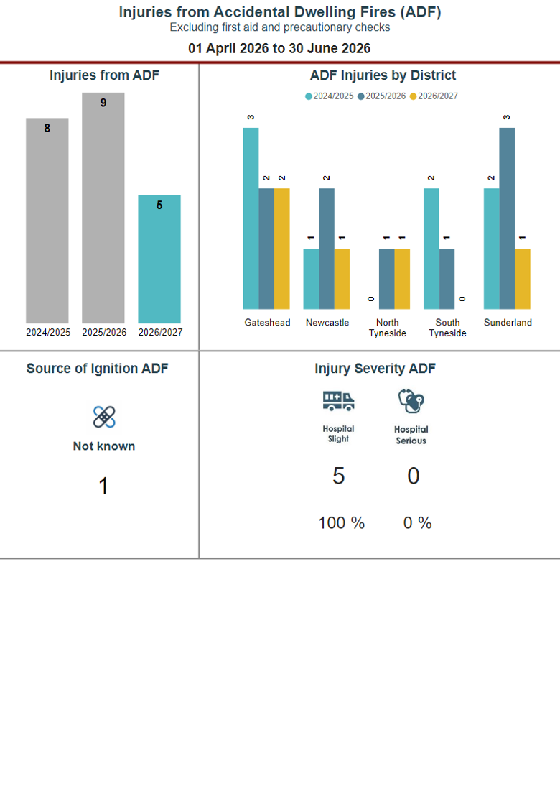

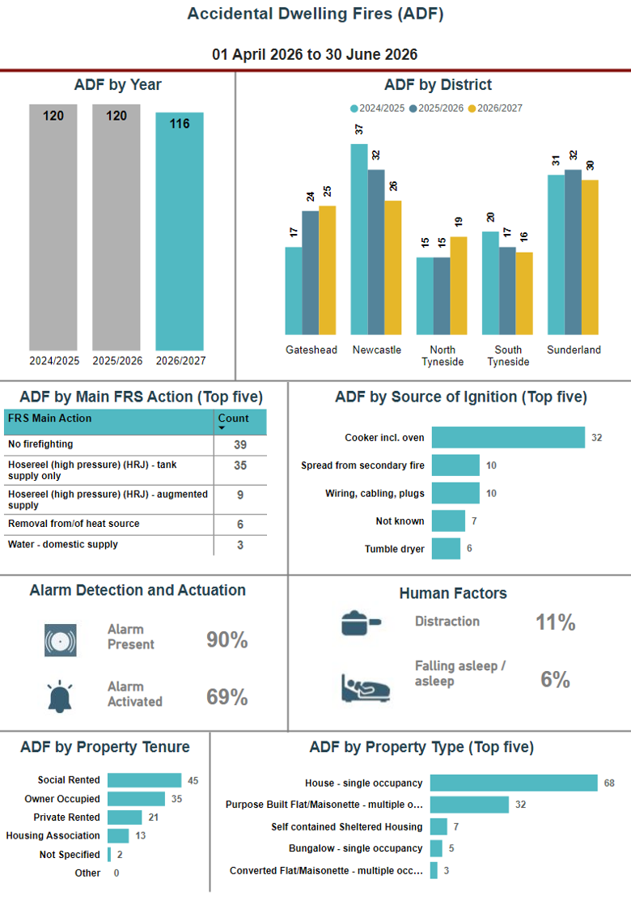

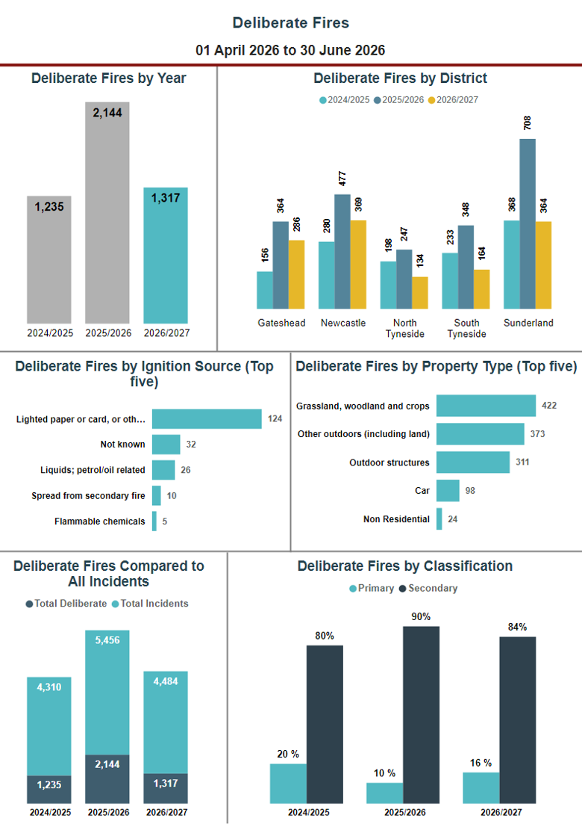

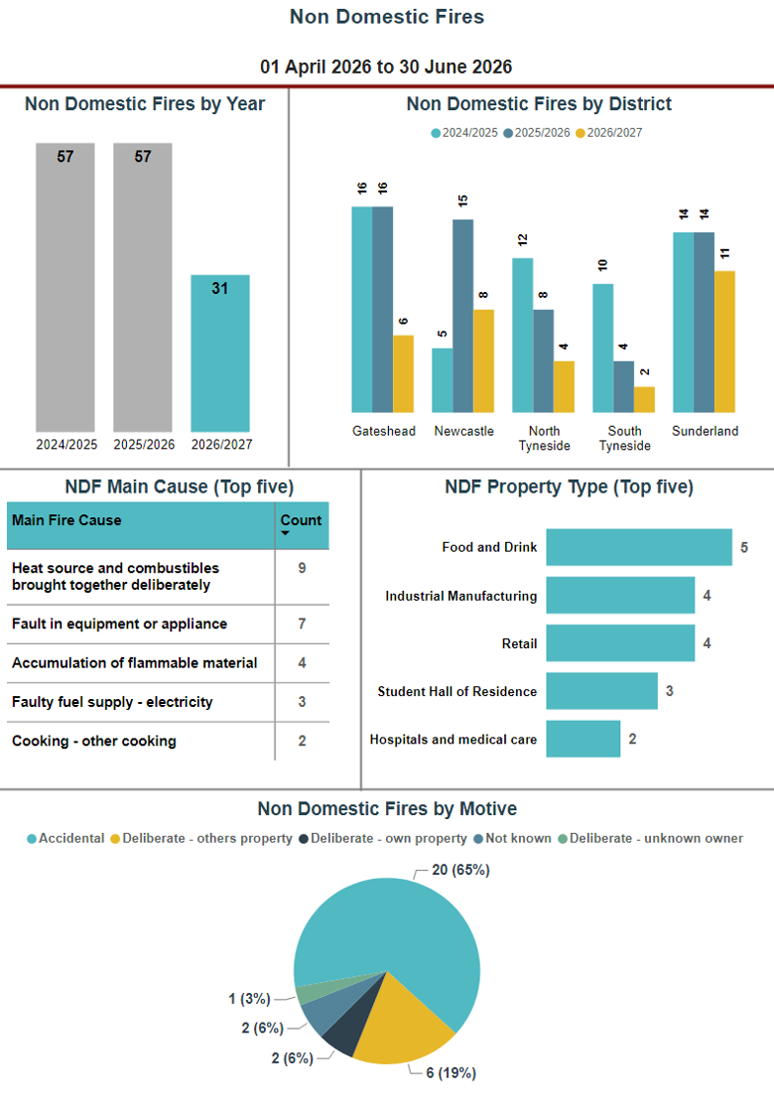

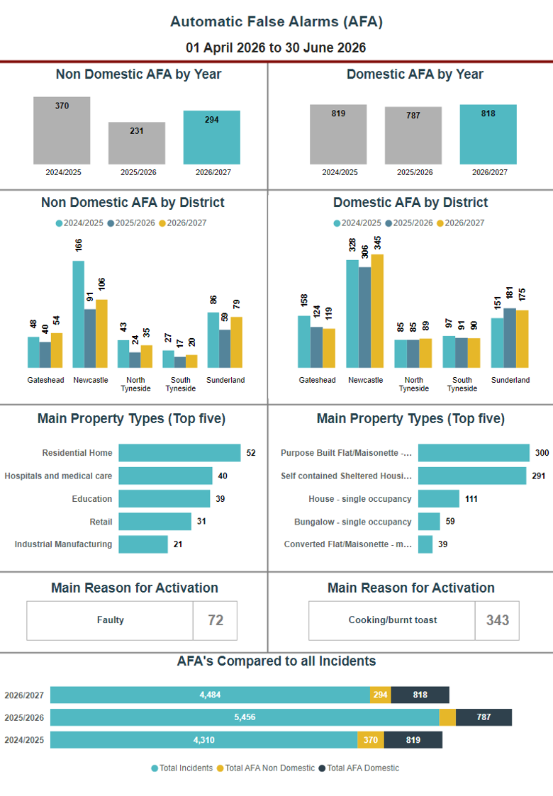

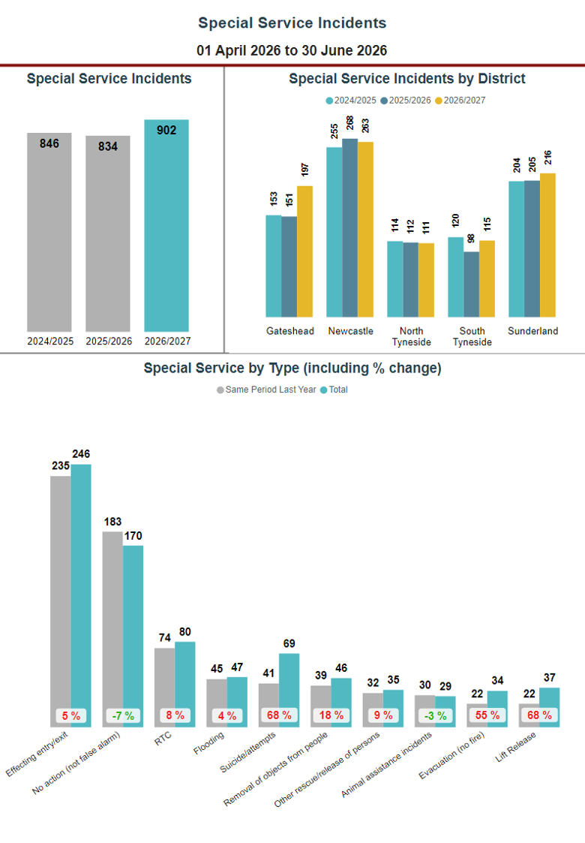

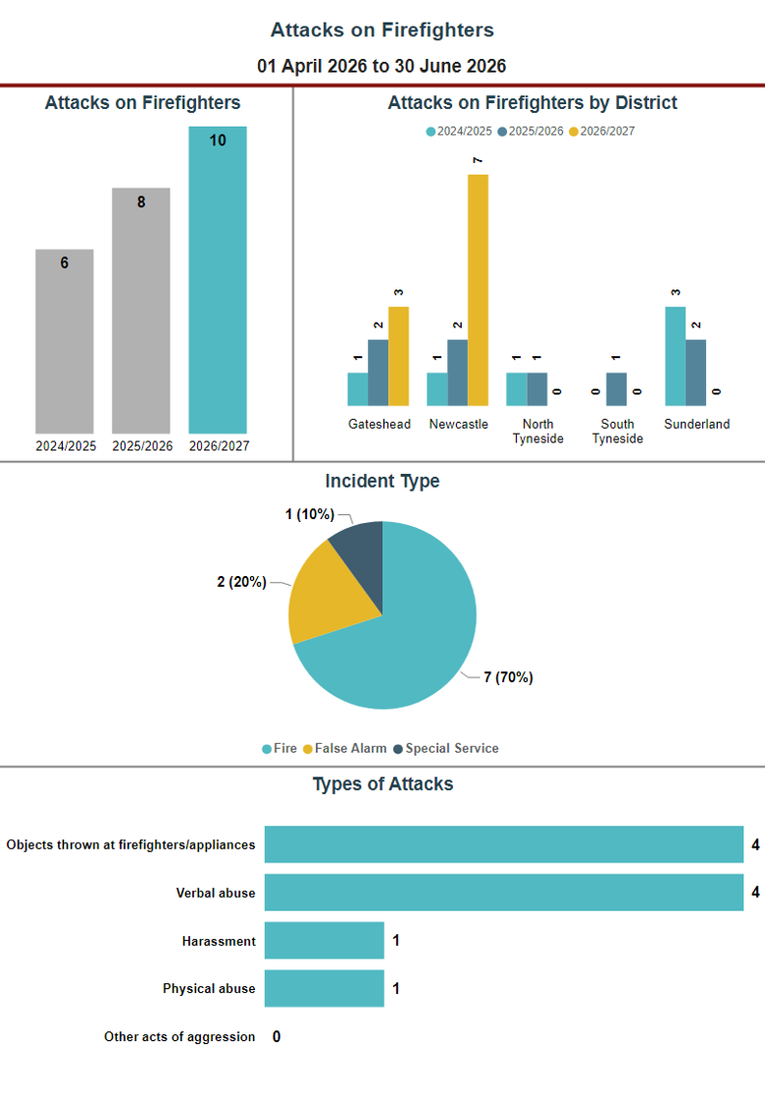

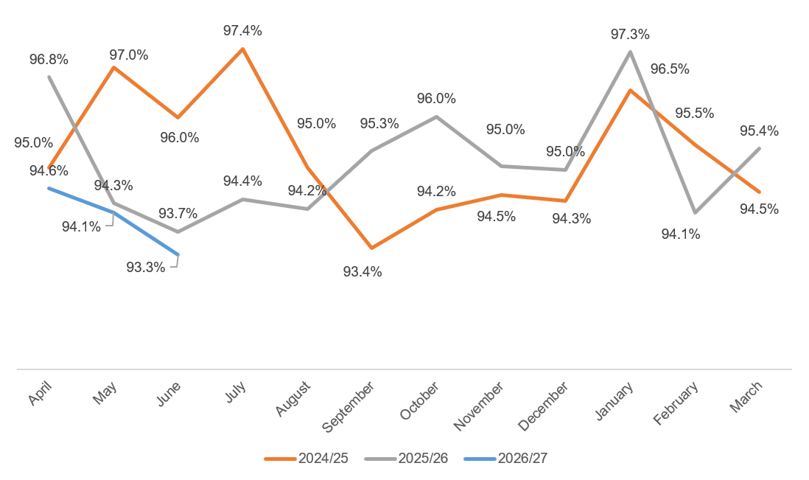
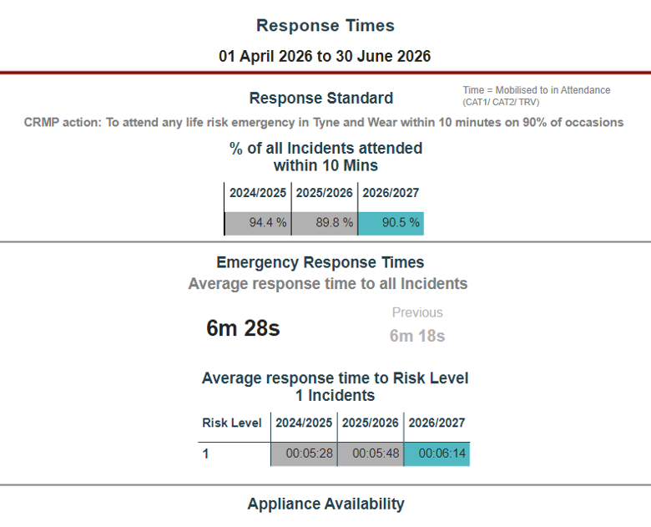

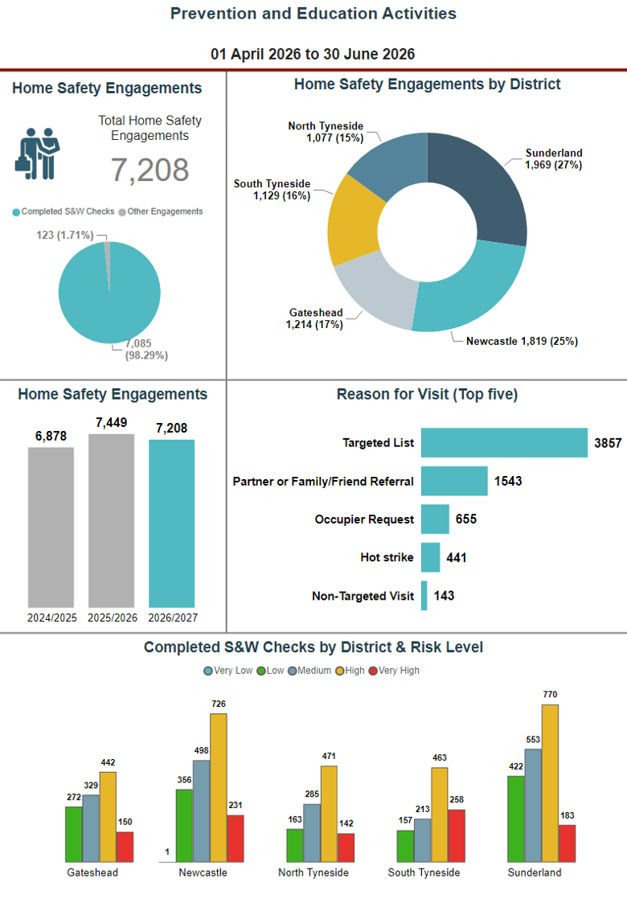

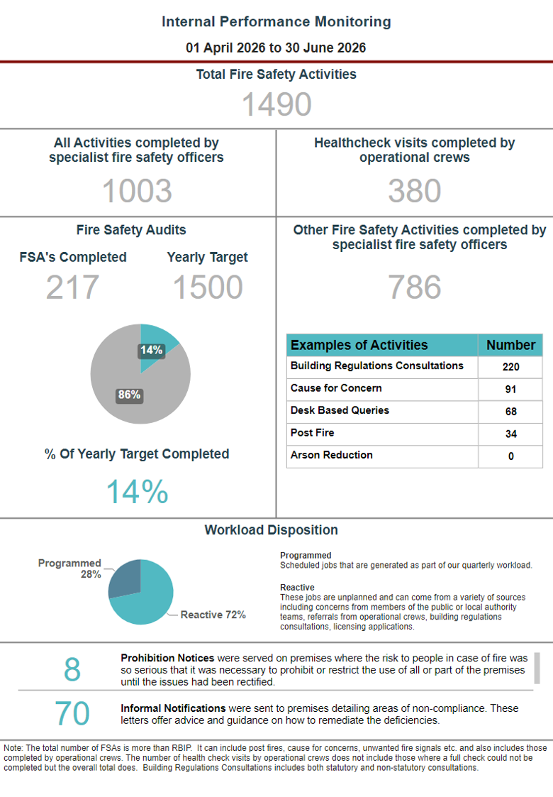

Internal Performance Monitoring

01 April 2026 to 30 June 2026

Internal performance indicators measure areas of performance that are important to us and are essential in helping us understand how well we are serving our communities. They set expectations to help managers to monitor and adapt to changing situations to assist in achieving our objectives.

The data contained in this section was ran on 04/08/2026

Q1 YTD Internal performance highlights compared with Q1 YTD 2025/26:

- Staff sickness was 2066 shifts lost, 5% increase (97) on Q1 2025/26. This is the equivalent of 2.4 days lost per person (FTE).
- The main reason for shifts/days lost is non work related ‘mental health’.
- 15 accidents to TWFRS personnel were reported in Q1 2026/27, a 88% increase (7) from Q1 2025/26.
- 24 near miss reports were submitted to Health and Safety, an increase of 140% (14) from 2025/26.
- Of the 11 vehicle accidents recorded in Q1 5 involved a pumping appliance Cat 1.
- There has been a total of £348,945.75 paid in overtime costs, an increase of 1%.
- 94% of interactive training packages have been completed.
- Overall operational competence is at 93%.

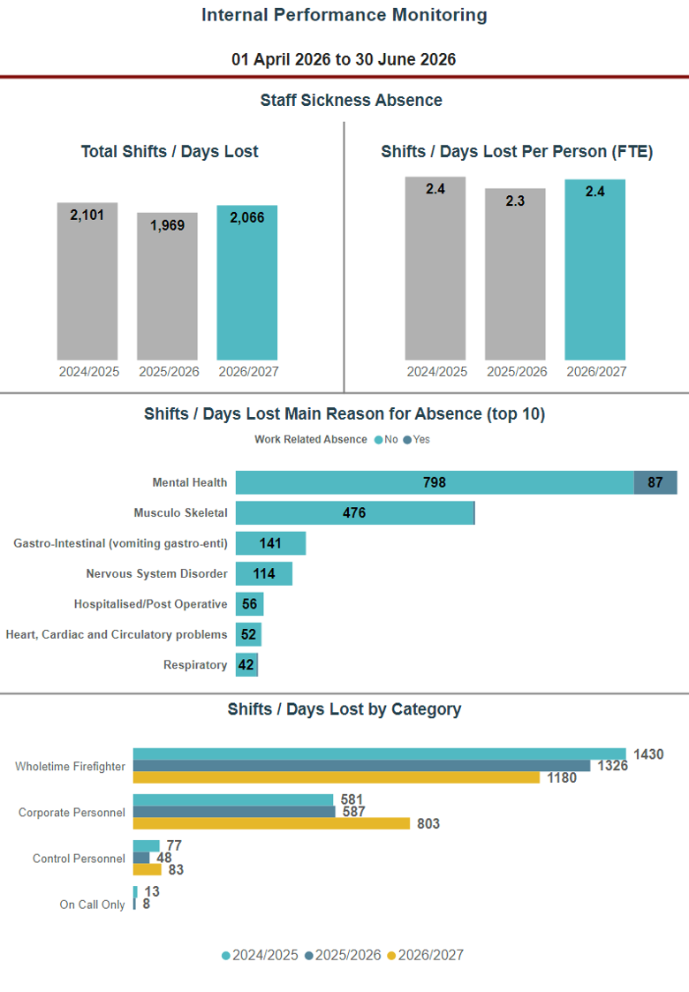

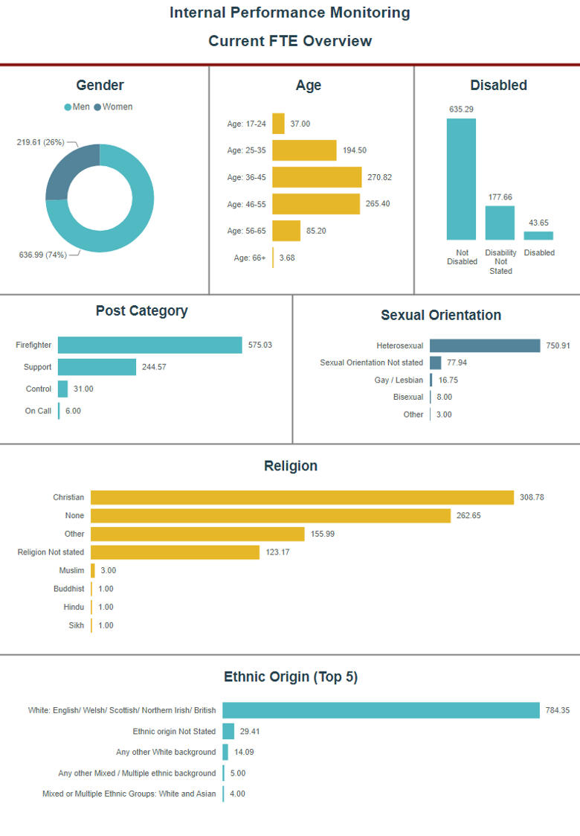

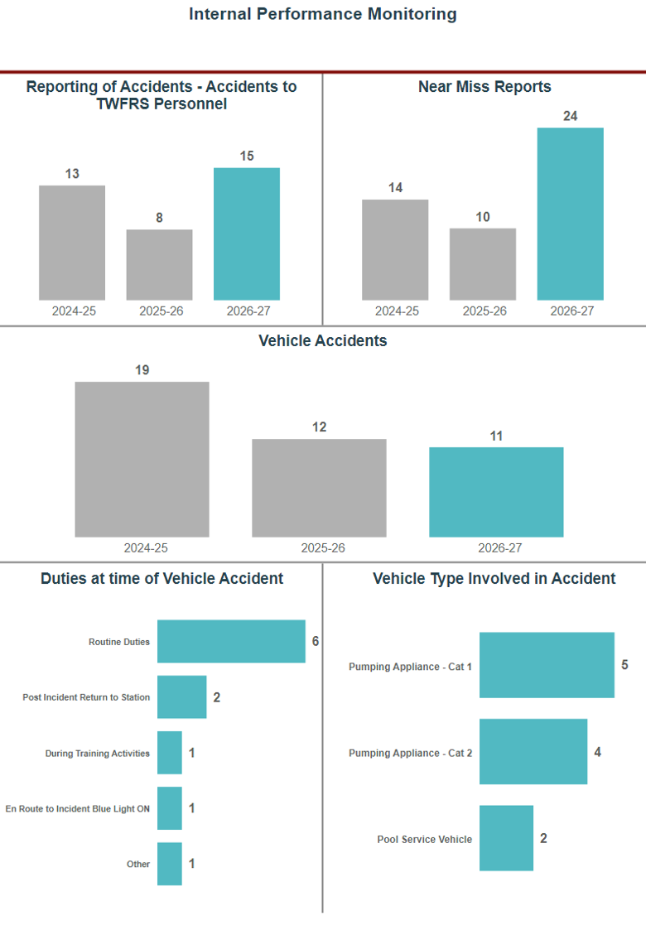

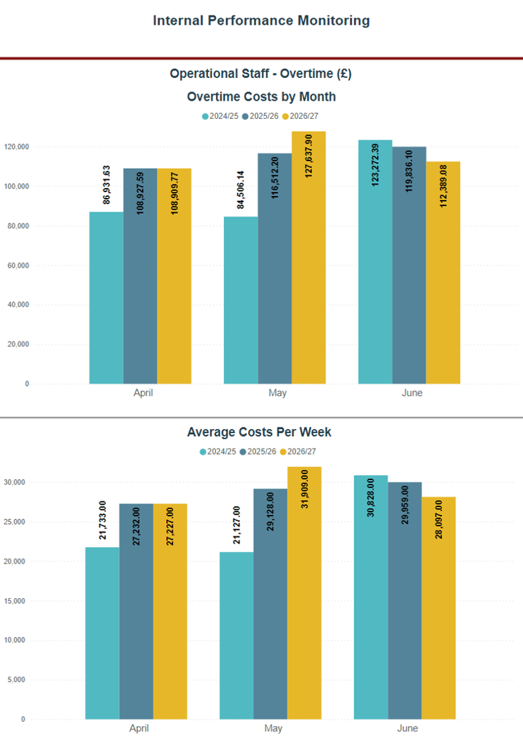
Please Note:
- Costs are shown for the month that the overtime was worked
- Overtime is paid in arrears in accordance with Payroll Attendance Records
- Costs are overtime payments only; no on costs are included

