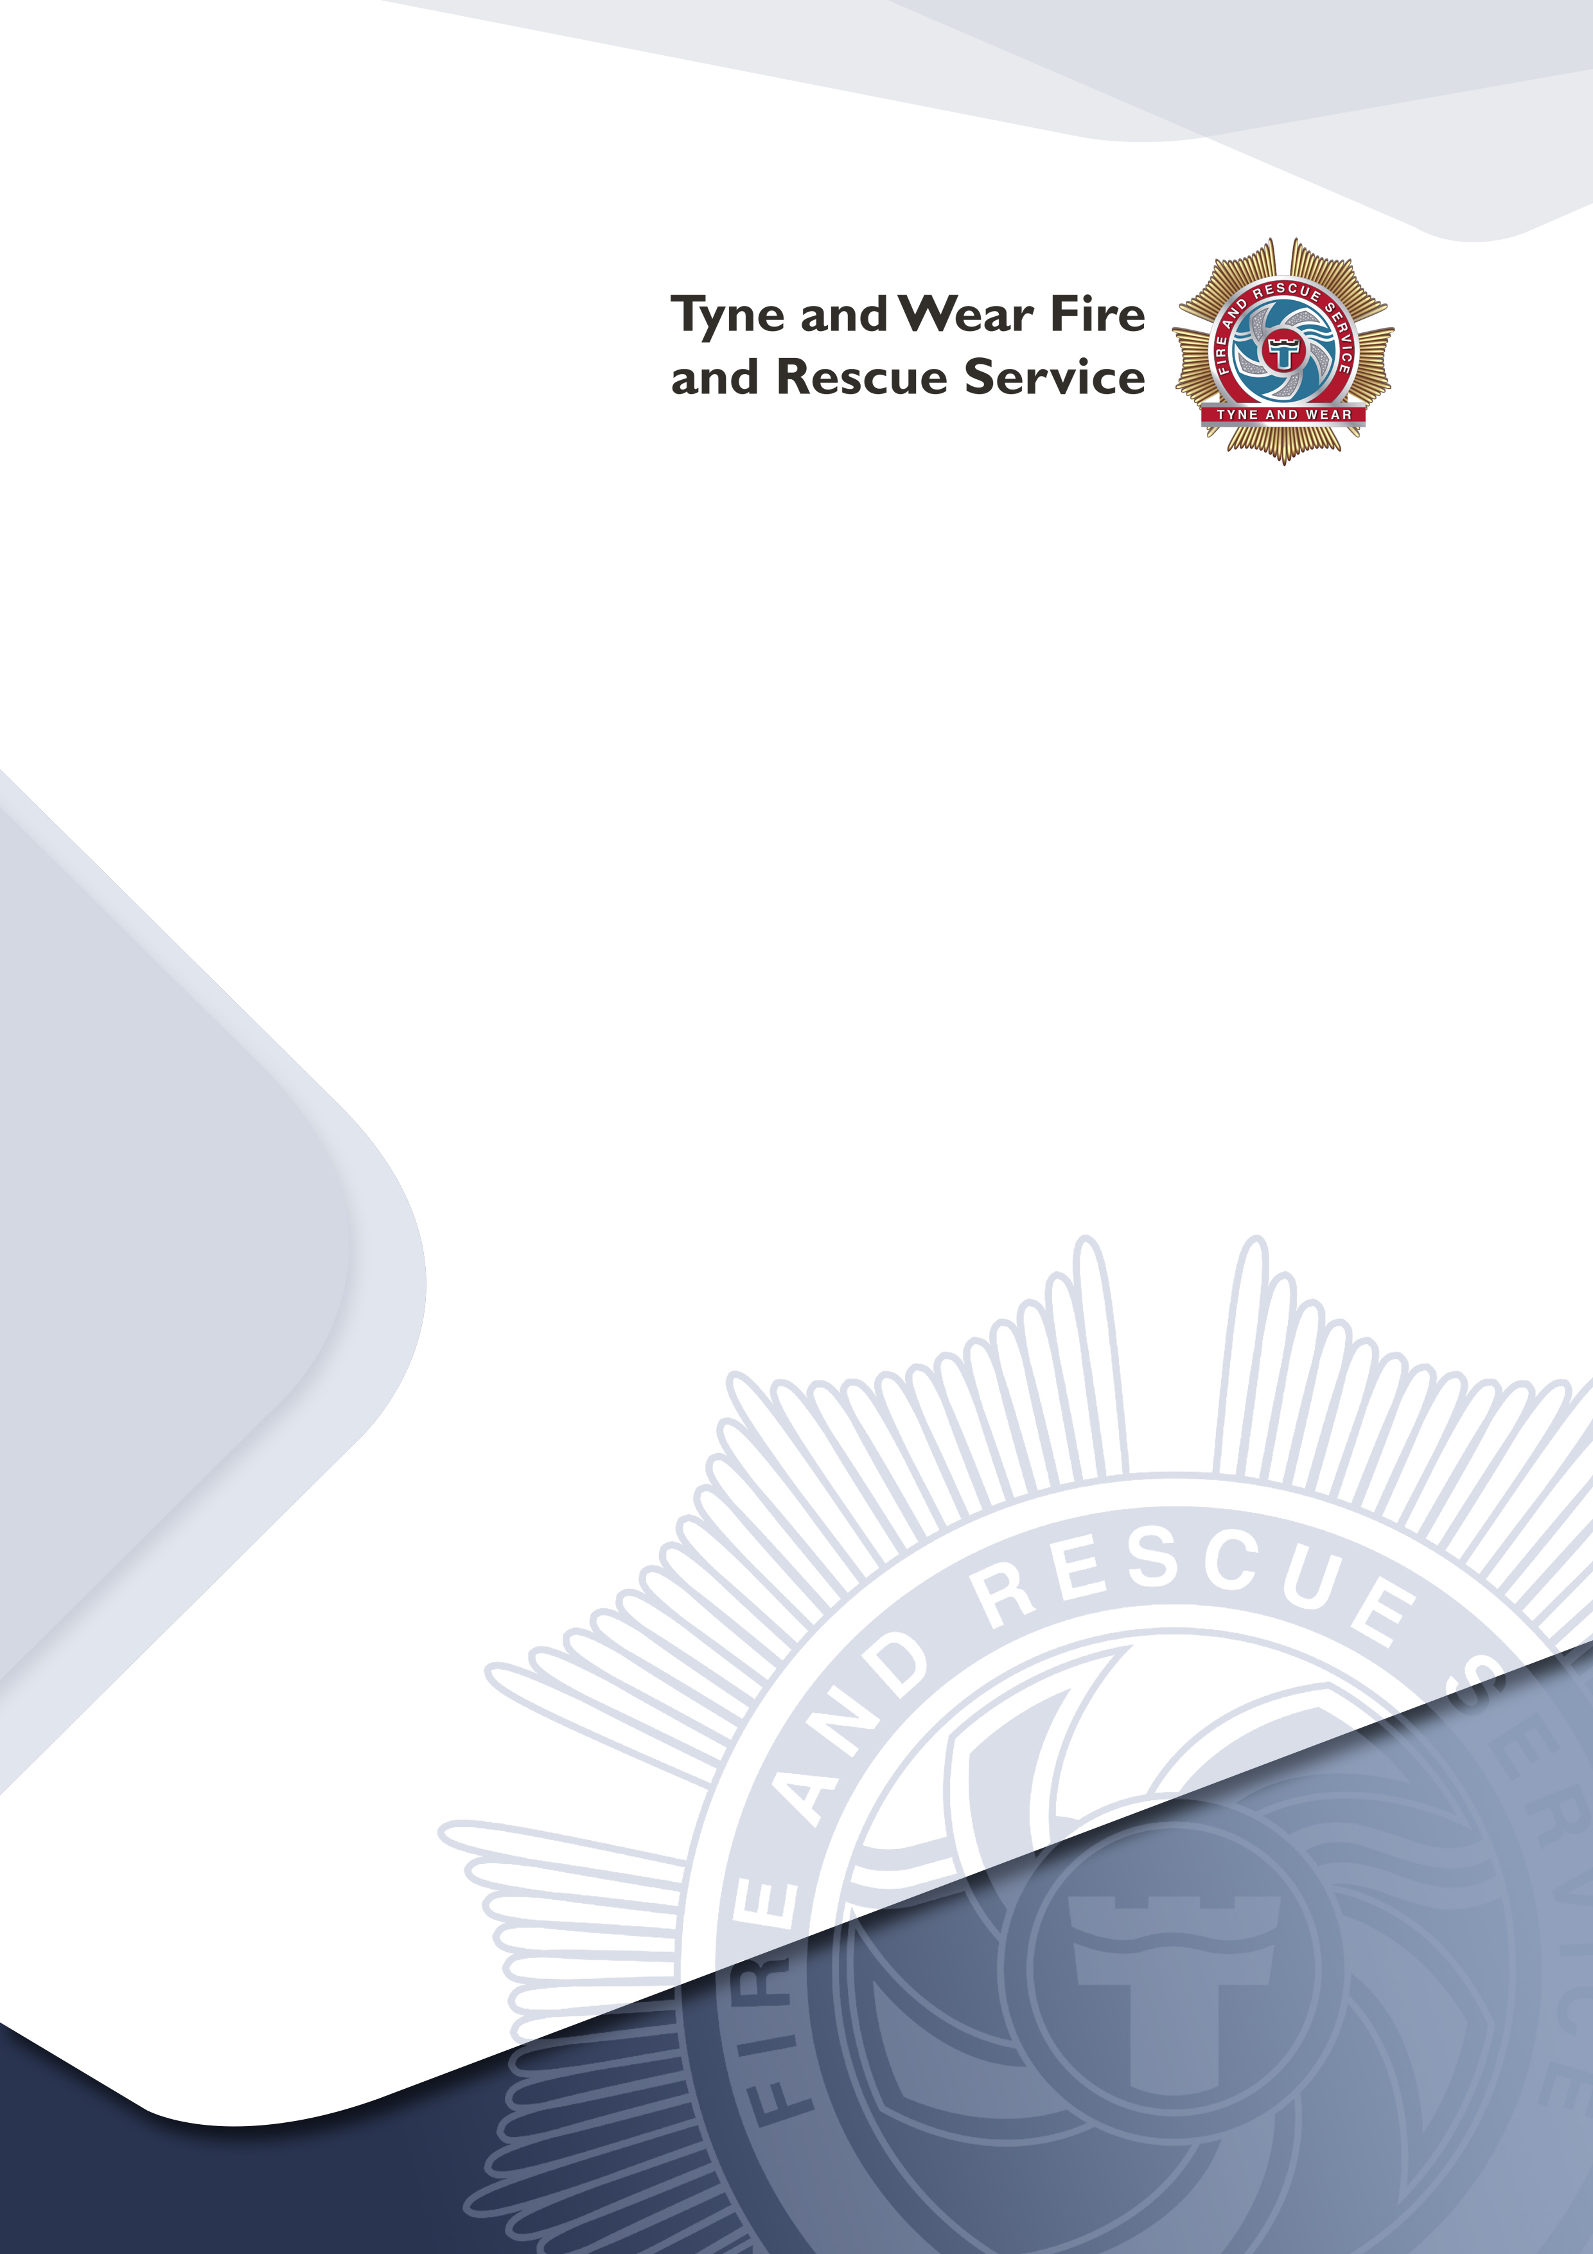
Introduction
Guide for reviewing your fire risk assessment

The Regulatory Reform (Fire Safety) Order 2005 (FSO) replaces previous fire safety legislation and places a duty on the responsible person to carry out and review a fire risk assessment.

Indemnity

This document has been produced as a tool to assist in reviewing a fire risk assessment. It is used entirely at your own risk to identify what you consider are your significant findings, and also whether you consider the information therein to be suitable and sufficient. It is in no way exhaustive, and Tyne & Wear Fire & Rescue Service accepts no liability for any circumstances which may arise as a result of using this tool.

Given the changing nature of laws, rules and regulations, and the inherent hazards of electronic communication, there may be delays, omissions or inaccuracies in the information contained in this guide.

While we have made every attempt to ensure that the information contained in this guide has been obtained from reliable sources, Tyne and Wear Fire and Rescue Service is not responsible for any errors or omissions, or for the results obtained from the use of this information.

Further Assistance & Reference

A set of FSO Guides are available to assist you in what you have to do to comply with fire safety law, help you to carry out a fire risk assessment and identify the general fire precautions you need to have in place. They are designed so that a responsible person, with limited formal training or experience, should be able to perform this task. If you read the guide and decide you are unable to apply the guidance then you should seek expert advice.

More complex premises will probably need to be reassessed by a person who has a comprehensive knowledge and training or experience in fire risk assessment.

It is strongly recommended that you refer to the relevant FSO Guide before reviewing your Fire Risk Assessment.

Review of your Fire Risk Assessment

As you are aware you have a responsibility to review your fire risk assessment from time to time, especially if there have been any changes to fuel, ignition, people, means of escape etc.

To assist you in that process this has been divided into sections to be used in conjunction with your original risk assessments.

- Premises Details
- Fire Safety Management Policy
- Sources of Fuel
- Sources of Ignition
- Identify People at Risk
- Spread of Fire
- Firefighting and Fire Detection
- Emergency Routes and Exits
- Maintenance, Servicing and Testing
- Dangerous Substances
- Luminous Discharge Tubes
- Firefighter Protection
- Your Fire Risk Assessment Result

N.B. Compliance:
Once you have reviewed a section, you will need to record the measures taken to ensure compliance with the legislation.

The completed forms should be stored with your reviewed fire risk assessment and be available for inspection.

- Premises Details

Have any of the details on the front of your fire risk assessment changed?

- Name
- Address
- Telephone Number
- Employer/Responsible Person
- Occupants
- Property Use
- Activity

- Fire Safety Management Policy

What changes have occurred since carrying out the last fire risk assessment that has affected your company policy on fire safety?

Suggested Measures:
- Roles and responsibilities of your employees has changed
- Fire marshals and wardens
- New employees
- New technology or new work practices
- Emergency procedures
- Assembly points
- Young persons
- New layouts/processes

Notes:

- Sources of Fuel

What changes have occurred since the last fire risk assessment have increased or decreased your fuel sources?

Suggested Control Measures:
- Flammable substances put away after use
- Combustible waste removed or stored safely
- Housekeeping kept in good order

- Sources of Ignition

What changes have occurred since the last fire risk assessment that have increased or decreased your ignition sources?

Suggested Control Measures:
- Avoid naked flames where possible
- Combustibles & heat sources kept separate
- Electrical PAT testing up to date
- Cooling vents on electrical equipment kept free from obstruction
- Multi-gang sockets/extension leads are being used correctly
- Fixed installations tested
- Appliances have correct fuses
- Old/worn wiring replaced
- Smoking Policy enforced
- No evidence of smoking in ‘Smoke Free Areas’
- Ash trays regularly emptied
- Designated areas kept clear of combustibles
- Arson policy up to date and applicable – any new risks included Cooking – ductwork filters regularly checked/cleaned
- ‘Hot work’ policy enforced
- Contractors made aware of company’s fire safety policy

Notes:

- Identifying People at Risk

What changes have occurred since the last fire risk assessment that has affected the occupancy of the premises?

Suggested Control Measures:
- Has the occupancy changed?
- Are additional people at risk? (Disabled, sleeping etc.) Consider the impact on means of escape, firefighting and detection

- Spread of Fire

What changes have occurred since the last fire risk assessment that affects the risk of fire on the premises and the risk of the spread of fire on the premises?

Suggested Measures:
- Compartment walls / ceilings - fire resistance
- Unoccupied areas
- Contents of rooms
- Early warning
- Automatic detection
- Housekeeping
- Fuel sources
- Ignition sources
- Segregation of risks
- Suppression systems i.e. sprinklers, water gas
- Sources of oxygen

Notes:

- Firefighting Equipment and Fire Detection

What changes have occurred since the last fire risk assessment that have affected your requirements for firefighting equipment or require a change to your detection system?

Suggested Control Measures:
- Check your fire routine notices, are they visible, legible and applicable - do you need more or need to re-site them?
- Check your fire alarm call points, are they visible, legible and applicable - do you need more or need to re-site them?
- Check everyone can hear the fire alarm
- Check your detectors, are they visible, legible and applicable – do you need more or need to re-site them?
- Check what is your fire alarm linked too i.e. dampers, smoke control, call centres – do they work?
- Check your firefighting equipment, are they visible, legible and applicable – do you need more or need to re-site them?
- Check which members of staff are trained to use your firefighting equipment – are they still employed, moved on – do you need to train new staff?
- Check emergency plan needs updating – are the people nominated still employed, moved on – do you need to train new staff?

- Emergency Routes and Exits

What changes have occurred since the last fire risk assessment that has affected the means of escape?

Suggested Control Measures:
- Check the means of escape from your premises – are the routes clear inside & outside, doors accessible, close easily, not damaged, easily openable without a key - do you need more or need to re-site them?
- Check where your exit signs are and are they visible, legible and applicable – do you need more or need to re-site them?
- How many doors have an electrical locking system – do they work, can they be overridden / is it fail safe?
- Check where your assembly points are and are they visible, legible, applicable and does all of your staff know where they are – do you need more or need to re-site them?
- Check where your emergency lights are, are they visible and applicable - do you need more or need to re-site them?
- Maintenance, Servicing and Testing

What changes have occurred since the last fire risk assessment that will affect your maintenance and testing regime?

Suggested Control Measures:
- Check the fire safety equipment provided in the premises is suitable and sufficient for any increase in risk
- All equipment must be tested and serviced to the code of practice/standard it was installed to, by a competent person
- Records of such tests and servicing should be available for inspection

- Dangerous Substances

What changes have occurred since the last fire risk assessment that affects dangerous substances?

Suggested Measures:
- New substances
- Existing substances - removed / replaced/ eliminated / mitigation / control measures
- People at risk Hazardous zones
- Arrangements to deal with accident, incidents and emergencies.
- Warning (including visual and audible alarm communications systems)
- Escape facilities Emergency procedures
- Procedures for fire
- Personal Protective Equipment (PPE)
- Fire drills / information for employees

Notes:

- Luminous Discharge Tubes

What changes have occurred since the last fire risk assessment that affects firefighter switched for luminous tubes?

Suggested measures:
- New luminous tubes
- Switches sited, coloured and marked correctly
- Notice sent to fire authority

- Firefighter Protection

What changes have occurred since the last fire risk assessment that affects the premises and any facilities, equipment and devices available for the use of or protection of firefighters?

Suggested measures:
- Dry risers
- Vehicle access
- Firefighting shafts - firefighting stairs, lobbies and lifts
- Fire Service communications systems
- Fire control centre - phased evacuation
- Hydrants
- Pump rooms
- Foam inlets
- Smoke control and ventilation systems
- Electrical supplies

Notes:

- Your Fire Risk Assessment Results

File your assessment results in a safe place, so they are readily accessible.

Remember: -
Do not forget to keep a duplicate copy of your results somewhere else, in case these are lost or destroyed, i.e. in a remote location or electronic archives.

Review
Check all the outstanding actions are reviewed and checked to see if they have been completed.

Use the above Fire Risk Assessment Review section to assist you in this.

Remember:-

The fire service may undertake an audit of your premises at any time

The Regulatory Reform (Fire Safety) Order 2005 states:
Risk Assessment
Article 9. – (1) The responsible person must make a suitable and sufficient assessment of the risks to which relevant persons are exposed for the purpose of identifying the general fire precautions he needs to take to comply with the requirements and prohibitions imposed upon him by or under this Order.

Failure to comply with this legal requirement could mean you have broken the law.

Onus of providing limits of what is practicable or reasonably practicable Article 34. In any proceedings for an offence under this Order consisting of a failure to comply with a duty or requirement so far as is practicable or so far as is reasonably practicable, it is for the accused to prove that it was not practicable or reasonably practicable to do more than was in fact done to satisfy the duty or requirement.

