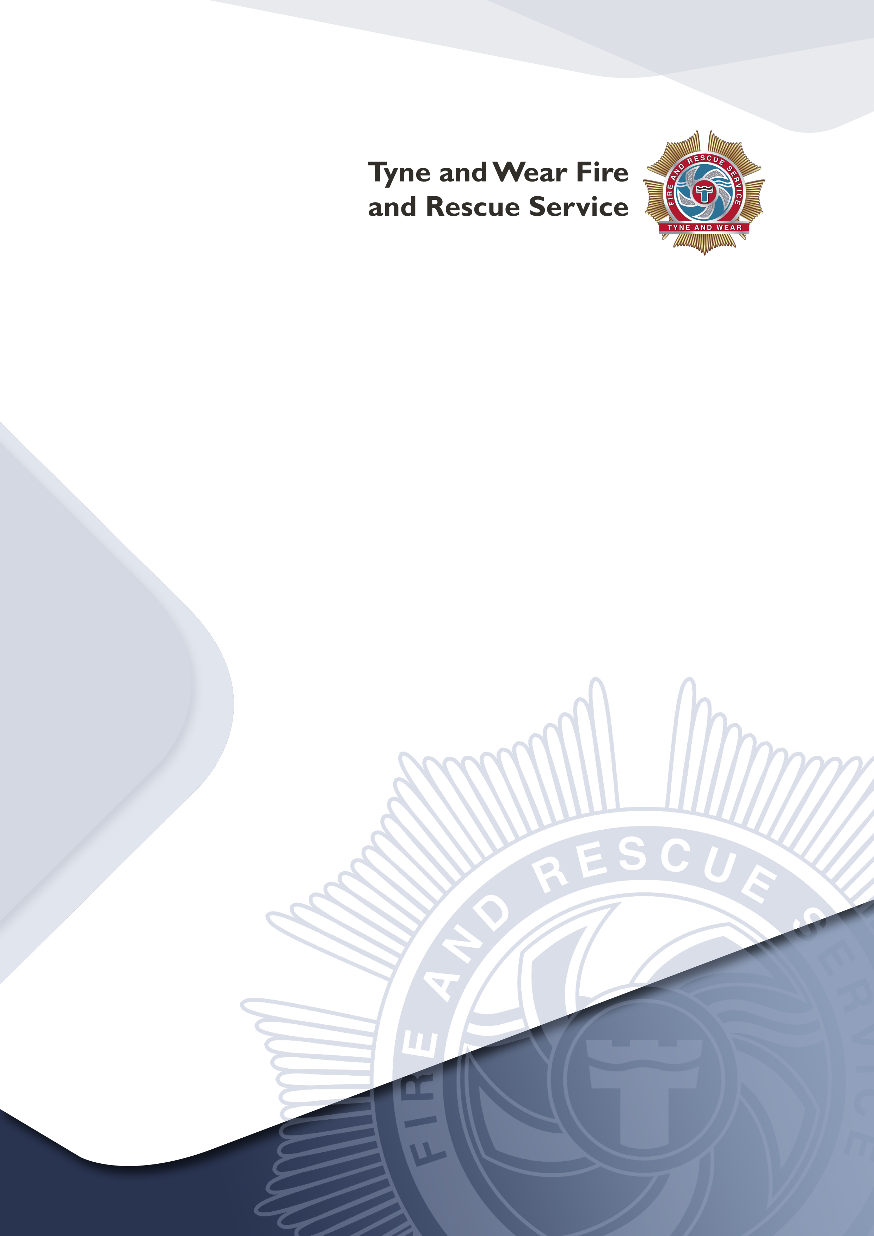
Fire Safety Lite Risk Assessment

For Simple Premises
Introduction
Fire Safety Risk Assessment
This form is intended to assist small businesses in carrying out the fire safety risk safety assessment. It is suitable for use in simple premises, with a simple internal layout and small numbers of people present, e.g. small offices, shops or industrial units and where people can escape unaided. In buildings with complicated escape arrangements, large numbers of people or high fire safety risk processes a more comprehensive fire safety risk assessment may be necessary.
The enclosed information follows a simple 5 step guide to completing a suitable assessment. The fire safety risk assessment does not need to be complicated, it should be a common sense review to identify the hazards (what could start a fire and what could burn), followed by consideration of the possible effects of a fire on people using the building. The important thing is that the fire safety risk assessment is systematic to ensure that every part of the premises is assessed. Every room, space or area, especially those not often used, should be included.
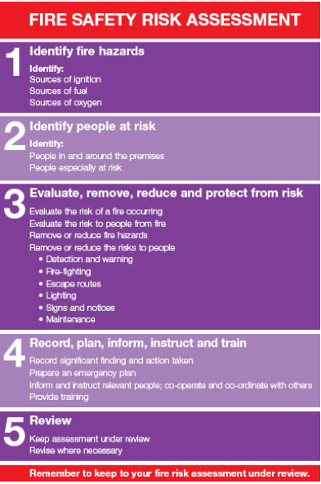

If you identify any significant risks you should consider if they can be reduced: first by removing the hazards and secondly by providing fire protection measures (e.g. automatic fire detection). These points should be addressed within the ‘What needs to be done to make each situation safe?’ section. If your premises are located within a larger building and if a fire in your business could affect your neighbours, you should share the findings of your fire safety risk assessment with your neighbours.
Your fire safety risk assessment must be kept up to date. It is important to update the assessment if anything is changed that might affect the risk (e.g. new ignition sources or use of flammable liquids etc.). If you identify that either the likelihood of a fire occurring or there is a risk to people you may want to consider seeking further assistance.
Emergency Plan
The findings of the fire safety risk assessment should be used to prepare an emergency plan. The plan should set out, what to do in case of fire, identify the escape routes, where to assemble and how to contact the Fire and Rescue Service. The fire safety equipment and any equipment that provides a possible ignition source (e.g. cooking, electrical appliances, etc.) should be regularly maintained to reduce the chance of fire and the risk to people. Frequent checks should also be made to make sure that the storage of materials, especially flammable materials, does not increase the risk of fire or prevent the use of escape routes. It is important that all members of staff know how to prevent fires and what to do if a fire does occur.
Indemnity
This document has been produced as a tool to assist you in completing a fire safety risk assessment of your premises. It is used entirely at your own risk to identify what you consider are your significant findings, and also whether you consider the information therein to be suitable and sufficient. It is in no way exhaustive and Tyne and Wear Fire and Rescue Service accepts no liability whatsoever for any circumstances which may arise as a result of using this tool.

Fire Risk Assessment

DETAILS
Company Name:
Premises Name:
Address:
Responsible Person:
Position:
Date of Assessment:
Carried out by:
Position:
Use of the Premises:
OCCUPANCY
Times in Use: |  |  | Weekdays: |  | Weekends:
Total Numbers of Staff: |  |  | Weekdays: |  | Weekends:
Total of all Persons Present: |  |  | Weekdays: |  | Weekends:
SIZE
Total Size of Premises (M²):
Number of Storeys:
Number of Basements:

Step 1- Identify Fire Hazards (Sources of Ignition)
Type |  | Location | Are existing control measures suitable?
Naked Flames |  |  |  |  |  |  | YES |  |  | NO
Portable Heaters and Heating Equipment |  |  |  |  |  |  | YES |  |  | NO
Electrical Equipment |  |  |  |  |  |  | YES |  |  | NO
Cooking Equipment |  |  |  |  |  |  | YES |  |  | NO
Work Process Risk(s) |  |  |  |  |  |  | YES |  |  | NO
Arson |  |  |  |  |  |  | YES |  |  | NO
Smoking Materials |  |  |  |  |  |  | YES |  |  | NO
Other Sources  (including Contractors) |  |  |  |  |  |  | YES |  |  | NO
 | If you have answered NO to any question above complete the details below: -
 | What needs to be done to make each situation safe? |  |  | Action required by whom |  | Date  due |  |  | Date  complete

Step 1- Identify Fire Hazards (Sources of Fuel and Oxygen)
Type |  |  |  | Location |  | Are existing control measures suitable?
Wood / Paper /Cardboard |  |  |  |  |  |  |  |  |  |  | YES |  |  |  |  | NO
Plastics / Rubber / Foam |  |  |  |  |  |  |  |  |  |  | YES |  |  |  |  | NO
Furniture and Fixings  (curtains, blinds etc) |  |  |  |  |  |  |  |  |  |  | YES |  |  |  |  | NO
Flammable Material  (gases / liquids / paints / thinners / glues) |  |  |  |  |  |  |  |  |  |  | YES |  |  |  |  | NO
Display Materials or Decorations |  |  |  |  |  |  |  |  |  |  | YES |  |  |  |  | NO
Waste Materials  (refuse, packaging) |  |  |  |  |  |  |  |  |  |  | YES |  |  |  |  | NO
Building Structure |  |  |  |  |  |  |  |  |  |  | YES |  |  |  |  | NO
Oxygen Supplies  (air conditioning units / bottles / piped supply) |  |  |  |  |  |  |  |  |  |  | YES |  |  |  |  | NO
 | If you have answered NO to any question above complete the details below: -
 | What needs to be done to make each situation safe? |  |  |  |  |  | Action required by whom |  |  | Date  due |  |  |  | Date  complete

Type | Findings
- Sensory Risk:

People with visual and / or hearing impairment(s)
- Mobility Risk:

People with physical impairments
- Familiarity Risk:

People who may be new to the premises and not familiar to its layout, seasonal workers, contractors, visitors or customers
- Numbers Risk:

Large numbers of people, small numbers of disabled people
- Lone Workers
Additional Information:
Step 2 – Identifying People at Risk

Step 3 - Evaluate, Remove, Reduce and Protect From Risk

Are ignition sources controlled to reduce the chances of fire? | YES |  | NO
Are combustible materials kept separate from ignition sources? | YES |  | NO
Are all doors and windows closed last thing at night? | YES |  | NO
Do you have a fire alarm system and is it adequate for your premises? | YES |  | NO
Will everybody be warned if the fire alarm operates? | YES |  | NO
Can everyone escape without assistance? | YES |  | NO
Is escape from fire available in more than one direction? | YES |  | NO
Are all fire exits easily identified by the correct signs? | YES |  | NO
Are escape routes free from obstruction and storage? | YES |  | NO
Are all doors on escape routes easily opened without a key? | YES |  | NO
Do all doors on escape routes open in the direction of escape? | YES |  | NO
Can everyone escape in a reasonable time? | YES |  | NO
Do you have emergency lighting? | YES |  | NO
Is the lighting adequate to illuminate circulation routes? | YES |  | NO
Do you have firefighting equipment? | YES |  | NO
Is the firefighting equipment adequate for the risks present? | YES |  | NO
Are your firefighting equipment maintained on an annual basis? | YES |  | NO
Are security arrangements sufficient to prevent unauthorised access? | YES |  | NO
Are housekeeping and general waste management adequate? | YES |  | NO
Are there any large open roof spaces or concealed ceiling voids? | YES |  | NO
Could a fire in your premise spread to another? | YES |  | NO
Can the fire service easily get to your premises? | YES |  | NO

If you have answered NO to any question above complete the details below: -
What needs to be done to make each situation safe? | Action required by whom | Date  due | Date  complete

Step 4 – Record, Plan, Inform, Instruct and Train
You must record your fire safety arrangements – this includes:
Have you made an emergency plan? |  |  |  |  |  |  |  |  | YES |  |  |  |  | NO
Have you provided fire instruction and staff training? |  |  |  |  |  |  |  |  | YES |  |  |  |  | NO
Are there records of fire drills to test your training and emergency plan? |  |  |  |  |  |  |  |  | YES |  |  |  |  | NO
Are there records of maintenance on all fire safety measures? |  |  |  |  |  |  |  |  | YES |  |  |  |  | NO
Have you recorded the significant findings of this assessment on Page 9? |  |  |  |  |  |  |  |  | YES |  |  |  |  | NO
 | If you have answered NO to any question above complete the details below: -
 | What needs to be done to make each situation safe? |  | Action required by whom |  |  |  |  | Date  due |  |  |  | Date  complete
Step 5 – Review

Your fire safety risk assessment must be kept up to date

Date of next review

It is recommended that you review your fire safety risk assessment regularly (recommended every 12 months) OR if you make changes to the layout of your premises, any changes to work processes, significantly increase the amount of combustible materials stored or displayed or sources of ignition, change your opening hours (e.g. to include night time opening etc) or any failures in your fire safety precautions then you should review your fire safety risk assessment.

Date of review | Signature | Print name

Simple premises fire safety risk assessment

Level of fire risk

In premises where there is a likelihood of a fire starting and spreading quickly, or a fire could start and grow undetected, and affecting the escape routes before people can use them, then the level of risk should normally be regarded at ‘higher’.

Such premises might include those where significant quantities of flammable materials are used or stored; ready sources of ignition are present, e.g. heat producing machinery and processes; premises where significant numbers of the people are present and might move slowly or be unable to move without assistance; and premises where the construction provides hidden voids or flues through which a fire could quickly spread.

In premises where there is a low occupancy level and all the occupants are able bodied and capable of using the means of escape without assistance; very little chance of a fire starting; few if any highly combustible or flammable materials or other fuels for a fire; fire is unlikely to spread quickly; and will be quickly detected so that all people will quickly know that a fire has occurred and can make their escape, then the risk can usually be regarded as ‘lower’.

In most cases however, the risk will usually be ‘normal’.

Taking into account both the active and passive fire prevention measures and general fire precautions observed at the time of this fire safety risk assessment, it is considered that the hazard from fire (likelihood of fire) at these premises is:

Low |  |  | Normal |  |  | High

In this context, a definition of the above terms is as follows: -

Low: Unusually low likelihood of fire as a result of negligible potential sources of ignition.

Normal: Normal fire hazards (e.g. potential ignition sources) for this type of occupancy, with fire hazards generally subject to appropriate controls.

High: Lack of adequate controls applied to one or more significant fire hazards, such as to result in significant increase in the likelihood of fire.

Note that, although the purpose of the above is to place the risk fire in context, the approach to fire safety risk assessment is subjective and for guidance only. All hazards and deficiencies identified in this fire safety risk assessment should be addressed by implementing all the recommendations contained in the following action plan.

The fire risk assessment should be reviewed regularly (recommended to be annually).

Simple premises

Fire safety action plan

Each item should be allocated a priority as follows: -
Priority 1: | Needs attention immediately
Priority 2: | Needs attention within 1 month
Priority 3: | Needs attention within the next 6 months
Priority 4: | Needs attention within the next 12 months

Ref: | Action  Required | Priority |  | Action by  Whom |  |  |  |  |  | Completion  Date
Example  001 | Remove waste from rear fire exit door | 1 |  | Manager |  |  |  |  |  | 01/01/2023
Page |  |  |  |  |  |  |  |  |  |  | of

For further information and guidance, please visit:

TWFRS’s websites Business safety pages

Fire safety law and guidance documents for business - GOV.UK

National Fire Chiefs Council Business fire safety tool

If you have any feedback relating to any of the above, suggestions on how to make our service more accessible for all members of the communities we serve or would like a copy of the comments, compliments or complaints leaflet, Please contact Headquarters using the following contact details:

Tel. 0191 4441664 or email FireSafetyAdminTeam@twfire.gov.uk

