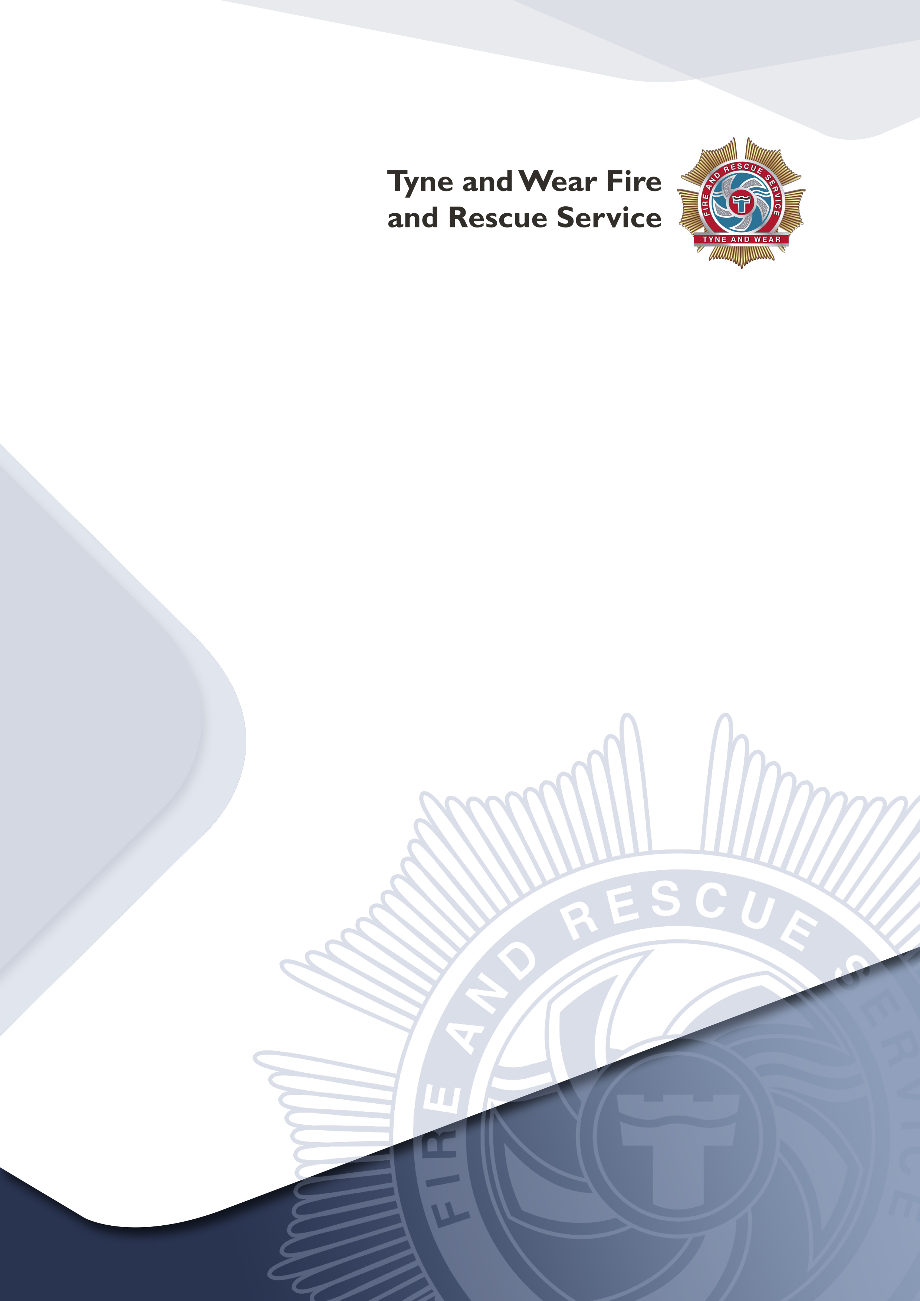

Your Fire Safety responsibilities under the Regulatory Reform (Fire Safety) Order 2005 and if applicable, the Licensing Act 2003
Occupancy Figures:
Calculations Guidance

The information contained within this leaflet is for guidance only. It is not a full and authoritative statement of the law and does not constitute legal advice. The leaflet does not replace, extend, amend or alter in any way the statutory provisions imposed on the responsible person under the Regulatory Reform (Fire Safety) Order 2005 and, if a licenced premises, the Premises Licence Holder under the Licensing Act 2003 or any subordinate legislation made nor statutory guidance issued in relation to these acts and orders.

Introduction

This leaflet is for the benefit of persons operating any premises open to the public. It provides guidance on general fire safety advice, completing your fire risk assessment and how to calculate safe occupancy figures.

Fire Risk assessment and the five steps to risk assessment.

This must be in writing

- Identify the hazards.

- Identify people at risk.

- Evaluate, remove, reduce and protect from risk.

- Record, plan, inform, instruct and train.

- Review.

Further guidance on the five steps to risk assessment can be found on the Tyne and Wear Fire and Rescue Service (TWFRS) website in the document ‘Making your premises safe from fire’ which is available in a number of languages. This can be found at http://www.twfire.gov.uk/firesafetyorder/

A template is available to download from the link below: http://www.twfire.gov.uk/firesafetyorder/

The adequacy of existing fire safety measures in a premise should be determined by carrying out a fire risk assessment.
The following checklist (although not exhaustive) has been compiled to enable applicants to address and manage fire safety measures in their building.

Has a fire risk assessment been carried out?

Has the maximum occupancy of the premises been determined?

Are all fire escape routes properly maintained and free from obstructions, goods or any material that constitutes a hazard to the route?

Are all stairways, corridors and lobbies kept free from combustible storage and furniture at all times?

Are all stairways, ramps and steps, comprising part of the means of escape, maintained in a safe condition with even and non‐slippery surfaces, with all floor coverings secured in position?

Are all self‐closing doors (other than those held open automatically) maintained in the closed position at all times and not provided with any means of keeping them in the open position, i.e. door chocks?

Are there any fire doors held open with automatic devices?

Do they close automatically on operation of the fire alarm?

Are all exit doors, through which people may have to pass, unlocked and free to open for persons leaving the premises?

Are arrangements in place so that persons with mobility difficulties are able to leave the premises safely in the event of fire? (Remember wheelchair users require a 900mm wide exit to safely evacuate your premises).

Are all floors, walls and ceilings kept in a satisfactory state of repair?

Are all surface finishes on walls, partitions and ceilings of such a standard to minimise fire spread?

Is all firefighting equipment readily available for use?

Is all firefighting equipment tested and maintained in efficient working order according to the appropriate standard?

Are all fire alarm tests, emergency lighting tests, electrical tests and fire training recorded?

Are all notices, signs and fire exit signs legible and unobstructed?

Has the electrical installation (fixed wiring) been checked within the last 5 years?

If special effects such as lasers, pyrotechnics, smoke machines, foam machines, etc. are to be used, what additional fire safety measures have been provided?

For premises with moveable seating, (village halls, etc.) are adequate gangway widths (1.1m) and seat way widths (300mm) provided? Please see example below.

Are the fire exits outward or inward opening? If the occupancy figure is for more than 60 people, then the doors should be outward opening.

Is there a procedure in place controlling the movement of persons through each floor level?

This is not a full and extensive risk assessment this is a basic fire safety check, there may be other issues that need to be taken into consideration, and therefore it is not a full and conclusive statement of fire safety requirements.

How to Calculate Safe Occupancy Figures

As part of your fire risk assessment, church halls, school halls, nightclubs and public houses should, as part of their fire risk assessment:

Calculate the maximum number of people that can safely resort within their premises at any one time. These figures should be incorporated in your risk assessment. It is your responsibility to produce the occupancy figures for your premises; it is no longer the responsibility of the fire service to produce these for you. Failure to produce these calculations may result in enforcement action by TWFRS as your risk assessment will not be suitable and sufficient.

TWFRS has produced a simple system for you to apply to your building that will allow you to calculate the safe number of persons allowable.

Please note. If your building has had its occupancy capacities determined under previous legislation, providing no material alterations have been made to the building then that previously determined figure should be acceptable. Make it part of your fire risk assessment for your building.

If you do not have an existing capacity figure, you have to consider the following method to determine this.

Method detailed in The Buildings Regulations “Approved Document B”

Firstly, calculate the maximum number of people allowable

The maximum allowed in the building is based on total usable floor space available. This is determined by:

- Dividing the space into distinct areas based on the use that area is put to.

- Then divide that space by the number in Table 1 below that relates to the use of that area, i.e. dance floor, bar area, seating, etc.

- Remember: toilets, corridors, stairways, do not count as usable space.
Please see worked example below … Calculation Example:

Using the table below; If you have a dance floor area 10m x 20m this equals 200m² of floor space, the following calculation will apply.

Occupancy Calculations (known as the Floor Space Factor)

To assist in calculating a safe and accurate occupancy figure the following tables have been extracted from The Building Regulations Approved Document – B

Types of Accommodation | Floor Space Factor m²/person
Standing areas, bars without seating within 2m of the serving point (bar). | 0.3
Assembly Halls, Dance Floors, Pop Concert Events. | 0.5
Dining rooms, Seated Lounge/Bar. | 1.0
Sports area | 2.0
Shop sales area | 2.0
Display, production or workshop area | 5.0
Office | 6.0
Shop (bulky goods) sales area | 7.0
Table 1: Floor space factor

Example Licensed Premises (dance floor area 10m x 20m)
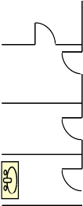
Bar

Kitchen

Office

Staff

Dance

floor

W.C

W.C

Boiler

In the example above:
- The dance floor can accommodate 400 persons (200 ÷ 0.5 = 400)

- The seated area can accommodate 18 persons (number of seats)

- The bar area can accommodate 30 persons (assuming 5m long bar x 2m depth) (10 ÷ 0.3 = 33)

- Total occupancy (400 + 18 + 33 =) 451 persons

Now establish the capacity of the exits

Once the theoretical occupancy of the room has been established, the available exits will need to be considered.

Please note the maximum occupancy of a room with only one exit will normally be 60 persons. This door may be inward opening.

If more than 60 people are present a minimum of two separate exits will be required which should open in the direction of escape.

Width of Escape Routes and Exits for licensed premises.

Maximum Number of Persons | Minimum Width mm outward opening door
60 | 750
110 | 850
220 | 1050
More than 220 | 5mm per person
Table 2: Escape widths

Measuring escape widths.

The width of a door should be the ‘effective clear width’ i.e. the minimum overall width allowing for door furniture:

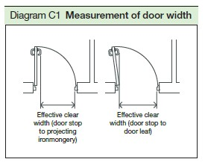

The width of any corridor or escape route is taken 1.5m above floor level; the minimum width should be measured i.e. including fixed obstructions (pipes etc.) Minimum Number of Escape routes and Exits from a room or storey.

Maximum Number of Persons | Minimum Number of Escape Route/Exits
60 | 1
600 | 2
More than 600 | 3
Table 3: Number of exits

Now the number of exits and the size has been established you will need to discount the largest exit to simulate a worst-case scenario where a fire removes the largest exit from use.

Worked example (1): discounting the largest exit
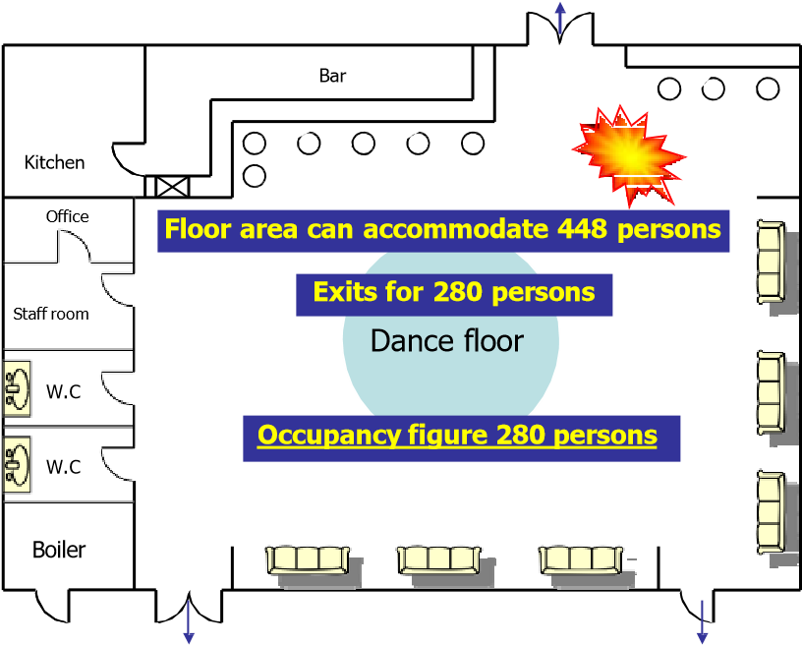
1050mm 220 persons
1050m 220 persons 750 mm 60 persons

- The example above is a dance floor that has just 3 exits.

- Without discounting an exit, the doors can accommodate 500 persons, however:

- A fire removes the largest exit from use; the customers and staff would turn their back on the fire and use the other 2 fire exits.

- The lower figure will be the occupancy of the room therefore:

- Total occupancy will be 280 persons

The 45-degree rule
If two exits are within 45 degrees of each other, a fire could take out both exits. Customers and staff will have to use the remaining exits.

Worked example (2): discounting due to the 45-degree rule
1050_{mm}
220 persons
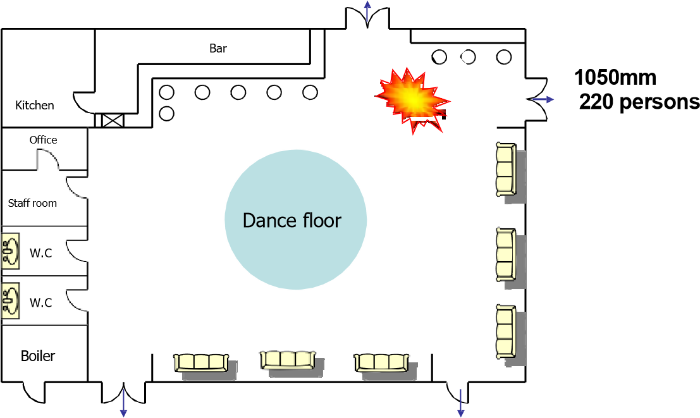
1050mm 750mm 220 persons 60 persons
- In this example, the dance floor has 4 exits but a fire near the two exits will remove both from use.

- The floor area can accommodate 448 persons

- Without discounting any exits, the doors can accommodate 720 persons however:

- The available exits can accommodate 280 persons

- The lower figure will be the occupancy therefore:

• Total occupancy will be 280 persons

• increasing the width of exits will increase the occupancy figures, for example if the 750mm exit is increased to 1050mm occupancy could be 440 persons.

Recommendations for theatre style seating

- The seating layout should be designed to ensure occupants can move easily to the fire exit.

- The distance between the front of one seat to the back of the row in front is known as the seatway width, this should not be less than 300mm as it forms the first part of an escape route.

- The aisles between rows of seats are known as gangways and should not be less than1100mm wide (for less than 60 people this can be reduced to 900mm); they should lead to a fire exit.

- Temporary seating for more than 50 persons should be secured in lengths of no less than 4 seats

- The occupancy of a lecture theatre with fixed seating is determined by the number of fixed seats within the premises.

Seatway width | Maximum number of seats in a row
mm | Gangway on one side | Gangway on two sides
300 to 324 | 7 | 14
325 to 349 | 8 | 16
350 to 374 | 9 | 18
375 to 399 | 10 | 20
400 to 424 | 11 | 22
425 to 449 | 12 | 24
450 to 474 | 12 | 26
475 to 499 | 12 | 28
500 or more | 12 | Limited by travel distance
Table 4: numbers of seats in rows

Available direction of escape | Areas with seating in rows (m) | Open floor areas (m)
In one direction only | 15 | 18
In more than one direction | 32 | 45
Table 5: Maximum travel distances in theatres

Exit routes and considerations

- Are they suitable for use by all occupants including the disabled?

- Easily, safely and immediately usable at all times

- Adequate for the number of people likely to use them

- Free from any obstructions, slip or trip hazards

- Well lit by normal and emergency escape lighting

- Available for access by the emergency services.

Evacuation time and Travel Distance

- In the majority of buildings, the risk can be classed as normal, higher risk premises may need a more rapid evacuation time.

- Normal risk – 2.5 minutes.

Measuring travel distances, these should lead to place of relative safety. These are –

- A protected stairway enclosure

- A separate fire compartment, from which there is a final exit to a place of ultimate safety (outside)

- The nearest available final exit to outside.

Travel Distance: The distance a person has to travel to a place of relative safety

Escape routes | Travel distance with seating in rows | Travel distance other areas
Where more than one route is provided | 20m High risk  32m Normal | 25m High risk  45m Normal
Where only a single escape route is provided | 10m High risk  15m Normal | 12m High risk  18m Normal
Table 6: Travel distances

Further Help & Advice

The Government has produced the following guides that further explain the risk assessment process and give some advice on what arrangements may be suitable to protect your premises.

Small & Medium Places of Assembly: This guide is intended for premises where the main use of the building or part of the building is as a small (i.e. premises accommodating up to 60 people) or a medium (i.e. premises accommodating up to 300 people) place of assembly. These usually include public houses.

Large Places of Assembly: This guide is intended for premises accommodating more than 300 people.

The full suite of documents that are available are:
- offices and shops
- factories and warehouses
- sleeping accommodation
- residential care premises
- educational premises
- small and medium places of assembly (holding 300 people or less)
- large places of assembly (holding more than 300 people)
- theatres, cinemas and similar premises
- open air events and venues
- healthcare premises
- animal premises and stables
- transport premises and facilities

These guides can be downloaded for free from:

https://www.gov.uk/workplace-fire-safety-your-responsibilities/fire-risk-assessments

These guides have been written to provide guidance for a responsible person, to help them to carry out a fire risk assessment in less complex premises. If you read the guide and decide that you are unable to apply the guidance, then you should seek expert advice from a competent person. Premises that are more complex will probably need to be assessed by a person who has comprehensive training or experience in fire risk assessment.

