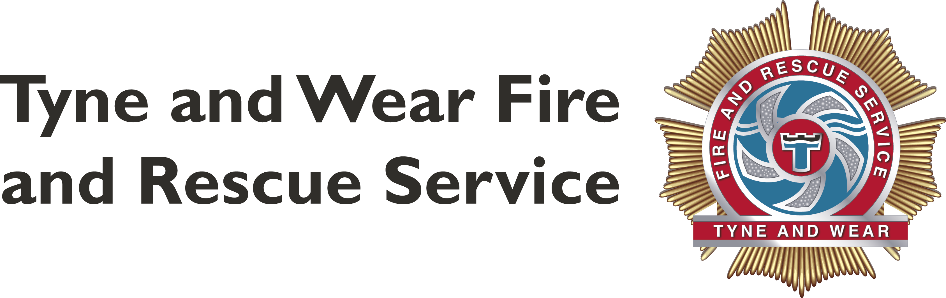
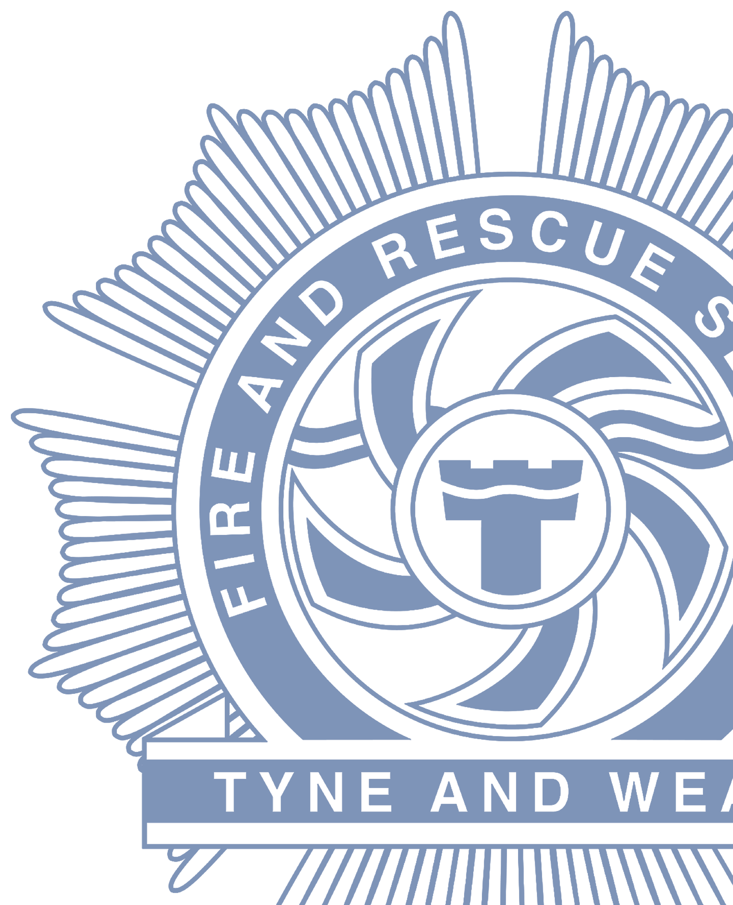
Fire Risk Assessments for use at Open Air Events

Fire Risk Assessment Food Concessions
Name of Unit/Stall:
Contact number on site:
Location on site:
In order to comply with relevant fire safety legislation you MUST complete a Fire Risk Assessment of your stall or unit.

The Risk Assessment needs to identify the fire hazards and persons at risk, you must endeavor to remove or reduce these risks and protect people from fire.
Failure to comply with this requirement will result in you being removed from the site.
You must be able to answer YES to the following questions.
This signed and completed form must be maintained available for inspection by the Fire & Rescue Service / Event Organiser / Council Officers at all times.
You must undertake a Fire Risk Assessment for your unit, which must be suitable for the circumstances.
You do not need to use this form, and may use another method if you wish, however, this form is considered to be suitable for most standard food units where customers do not enter the unit

 | Do you have an inspection / gas safety certificate for the appliances and pipe work (copy to be available for inspection) and are all hose connections made with “crimped” fastenings? |  | Yes | No
 | Are cooking appliances fixed securely on a firm non-combustible heat insulating base and surrounded by shields of similar material on three sides? |  | Yes | No
 | Do the shields provide an adequate and effective barrier of at least 600 mm between the heat source and any combustible material? |  | Yes | No
 | Have you ensured that no combustible materials can be blown against, or fall onto the apparatus? |  | Yes | No
 | Are the LPG cylinders kept outside, or within a specific ventilated unit, secured in the upright position and out of the reach of the general public? |  | Yes | No
 | Do you ensure that only those cylinders in use are kept at your unit/stall?  (Spares should be kept to a minimum and in line with any specific conditions for the event) |  | Yes | No
 | Are the gas cylinders readily accessible to enable easy isolation in case of an emergency? |  | Yes | No
 | Are the cylinders located away from entrances, emergency exits and circulation areas? |  | Yes | No
 | Do you ensure that gas supplied is isolated at the cylinder, as well as the appliance when the apparatus is not in use and appliances are fitted with full flame safety devices on all burners that are not readily visible? |  | Yes | No
 | Do you ensure replacement cylinders are fitted in the open air away from the sources of ignition? |  | Yes | No
 | Is a member of staff, appropriately trained in the safe use of LPG, present in the unit at all times? |  | Yes | No
 | Are the structure, roofing, walls and fittings of your stall or unit flame retardant?  (Certificates of compliance will normally be required) |  | Yes | No
 | Where necessary, are there sufficient directional signs indicating the appropriate escape route and do they comply with current regulations? |  | Yes | No
 | Are the exits maintained available, unobstructed, and unlocked at all times the unit is in use? |  | Yes | No
 | If you intend to trade during the hours of darkness, do you have sufficient lighting inside and outside your unit? |  | Yes | No
 | If the normal lighting failed would the occupants be able to make a safe exit?  (Consider back up lighting) |  | Yes | No
 | Do you have an adequate number of fire extinguishers/fire blankets available in prominent positions and easily available for use? |  | Yes | No
 | Has the fire-fighting equipment been tested within the last 12 months?  Note: a certificate of compliance will normally be required |  | Yes | No
 | Have your staff been instructed on how to operate the fire-fighting equipment provided? |  | Yes | No
 | Have your staff been made aware of what to do should an incident occur, how to raise the alarm, evacuate the unit and the exit locations? |  | Yes | No
 | Are you aware that petrol generators are not permitted on site? |  | Yes | No
 | Have you identified all ignition sources and ensured that they are kept away from combustible materials? |  | Yes | No
 | Have you identified combustible materials that could promote fire spread beyond the point of ignition such as paper/cardboard, bottled LPG, etc. and reduced the risk of them being involved in an incident? |  | Yes | No
 | Do you have sufficient refuse bins, and do you ensure that all refuse is disposed of correctly, out of reach of the public? |  | Yes | No
 | If any staff sleep in the stall is there a working smoke detector and a clear exit route at night?  Note: Persons should not be allowed to sleep within a high risk area and some Authorities and events do NOT allow any sleeping within units |  | Yes | No
If the answer to any of the above question is “No”
Please detail the actions you have taken to remedy the situation.
Stallholder/Responsible Person:
Signature: |  | Date:
Print name: |  | Designation:
Company:

PLEASE NOTE
This document does not preclude you from possible prosecution or removal from the site by the organisers should a subsequent inspection reveal unsatisfactory standards

Fire Risk Assessment
Traders and Market Stalls
Name of Unit/Stall:
Contact number on site:
Location on site:
In order to comply with relevant fire safety legislation you MUST complete a Fire Risk Assessment of your stall or unit.

The Risk Assessment needs to identify the fire hazards and persons at risk, you must endeavor to remove or reduce these risks and protect people from fire.
Failure to comply with this requirement will result in you being removed from the site.
You must be able to answer YES to the following questions.
This signed and completed form must be maintained available for inspection by the Fire & Rescue Service / Event Organiser / Council Officers at all times.
You must undertake a Fire Risk Assessment for your unit, which must be suitable for the circumstances.
You do not need to use this form, and may use another method if you wish, however, this form is considered to be suitable for most standard food units where customers do not enter the unit

 | Are adequate exits provided for the numbers of persons within the unit or stall?  (Are your staff and customers able to evacuate easily if the normal exit is blocked?) |  | Yes | No
 | Where necessary, are there sufficient directional signs indicating the appropriate escape route and do they comply with current regulations? |  | Yes | No
 | Are the exits maintained available, unobstructed, and unlocked at all times the premises are in use? |  | Yes | No
 | If the normal lighting failed would the occupants be able to make a safe exit?  (Consider back up lighting) |  | Yes | No
 | Do you have an adequate number of fire extinguishers/fire blankets available in prominent positions and easily available for use? |  | Yes | No
 | Has the fire-fighting equipment been tested within the last 12 months?  Note: a certificate of compliance will normally be required |  | Yes | No
 | Have your staff been instructed on how to operate the fire-fighting equipment provided? |  | Yes | No
 | Have your staff been made aware of what to do should an incident occur, how to raise the alarm, evacuate the unit, and the exit locations? |  | Yes | No
 | Have you identified combustible materials that could promote fire spread beyond the point of ignition such as paper/cardboard, bottled LPG etc and reduced the risk of them being involved in an incident? |  | Yes | No
 | Have you identified all ignition sources and ensured that they are kept away from all flammable materials? |  | Yes | No
 | Are the structure, roofing, walls and fittings of your stall or unit flame retardant?  Note: certificates of compliance will normally be required |  | Yes | No
 | If any staff sleep in the stall is there a working smoke detector and a clear exit route at night? Note: Persons should not be allowed to sleep within a high risk area and some Authorities and events do NOT allow any sleeping within units. |  | Yes | No
 | Are you aware that you must not stock or sell certain items, i.e. fireworks, garden flares, household candles, tea lights, etc? |  | Yes | No
 | Do you have sufficient bins for refuse? Is all refuse kept away from your unit? |  | Yes | No
 | Are you aware that petrol generators are not permitted on site? |  | Yes | No
If you use LPG
 | Do you have an inspection / gas safety certificate for the appliances and pipe work (copy to be available for inspection) and are all hose connections made with) crimped fastenings? |  | Yes | No
 | Are the cylinders kept outside, secured in the upright position and out of the reach of the general public? |  | Yes | No
 | Are appliances fixed securely on a firm non-combustible heat insulating base and surrounded by shields of similar material on three sides? |  | Yes | No
 | Are the cylinders located away from entrances, emergency exits and circulation areas? |  | Yes | No
 | Are the gas cylinders readily accessible to enable easy isolation in case of an emergency? |  | Yes | No
 | Do you ensure that all gas supplies are isolated at the cylinder, as well as the appliance when the apparatus is not in use? |  | Yes | No
 | Do you ensure that only those cylinders in use are kept at your unit/stall? (Spares should be kept to a minimum and in line with any specific conditions for the event) |  | Yes | No
 | Is a member of staff, appropriately trained in the safe use of LPG, present in the unit/stall at all times? |  | Yes | No
If the answer to any of the above question is “No”
Please detail the actions you have taken to remedy the situation.
Stallholder/Responsible Person:
Signature: |  | Date:
Print name: |  | Designation:
Company:

PLEASE NOTE
This document does not preclude you from possible prosecution or removal from the site by the organisers should a subsequent inspection reveal unsatisfactory standards

