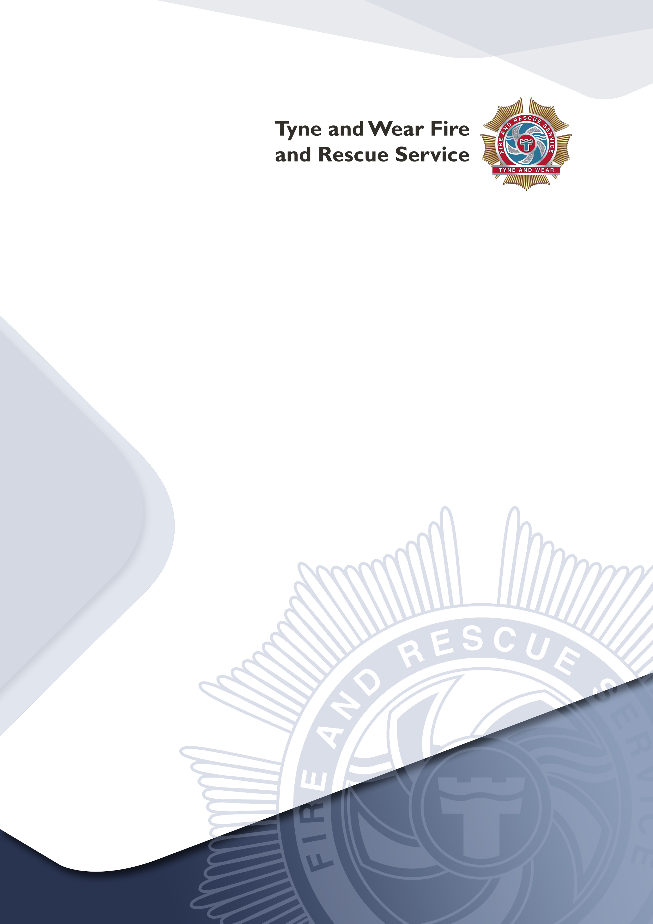

How to use this guide
Wholetime Firefighter
Recruitment

Applicant Guidance 2023

This booklet is designed to help guide you through the application process.

You can read it all in one go, or refer to each section as you reach each stage of the process.

Before you submit your application, please make sure that you read Section 1:

- Eligibility – this will help you identify if your application will be accepted

- How good a match are you? – this will help you understand what the job involves and what we look for in a candidate

- The selection process (summary) – this will give you an overview of the deadlines for each stage of the process

If at any point you have a question, please check our Frequently Asked Questions (FAQs) before you contact us. The FAQs are available in the Application Guidance Document Appendices. If you do need to contact us, you can do this by emailing Recruitment@twfire.gov.uk.

If you have a disability and require reasonable adjustments to help you take part in the recruitment and selection process, please note this on the application form and we will contact you to ask what your disability is and to request any supporting information such as a copy of your Education Health Care Plan (ECHP) or Statement.

GDPR Statement

How we use your data
- We will hold and process your data for the purpose of administrating the selection process for wholetime firefighters.
- We may use your data to ask you to participate in our evaluation surveys.
- We are committed to protecting your data and it will only be used for the purpose of recruitment.
- We will hold your data in line with our current retention schedules after which time it will be permanently deleted.
- You have the right to withdraw your consent for us to hold your data at any time. This can be done by emailing DPO@twfire.gov.uk.

Contents

Section 1 5
- Eligibility 5
- How Good A Match Are You? 5
- What Firefighters Do 6
- What we look for in a candidate 6
- Skills & Qualities 6
- Selection Process Timeline 7
- The journey to becoming a firefighter 8
- Pay & Benefits 8
- Hours of Work 8
- Pension Benefits (Summary) 9
- Annual leave 9
- Work/Life balance 9

Section 2 10
- Stage 1 Applications Process 10
- When to apply 10
- How to apply 100
- Stage 2 Online Tests 11
- Important information before you begin 111
- About the tests 111
- Behaviour Style Questionnaire (BSQ) 122
- Situational Judgement Test (SJT) 122
- Numerical Test 122
- Verbal Reasoning Test 122
- Mechanical Test 122
- Stage 3 Bleep Test 133
- What is the Bleep Test? 133
- Improve your fitness 133
- Stage 4 Role Related Tests 144
- What is involved? 144
- Ladder Climb 155
- Ladder Lift 155
- Casualty Evacuation 155
- Equipment Carry 155
- Equipment Assembly 155
- Enclosed Space 155
- Stage 5 Competency Based Interviews and Online Test Validation 166
- How to prepare for the interview 166
- Online Tests Validation 166
- Stage 6 Fitness and Medical 177
- Fitness Test 177
- What is involved in the medical? 178
- Stage 7 Pre-employment Checks 19
- Pre-employment checks 19

Section 1

Eligibility

To apply for the process you must meet all of the eligibility criteria set out below:

- you must be aged 18 years or over by June 2023
- you must have the right to work in the UK

A ‘Standard’ Disclosure and Barring Service (DBS) check is a requirement for the role. Please refer to the Frequently Asked Questions for information/advice regarding convictions.

An ability to confidently swim at least 25 meters is desirable.

How Good A Match Are You?

The journey to becoming a firefighter once you have been offered the job involves a lot of physical, practical and theoretical training.

How fit you need to be

As a guide, you are likely to have the minimum level of cardiorespiratory fitness for UK firefighting if you can:

  - Run 1.5 miles (2.4 kilometres) continuously in 12 minutes or less (this is equal to running 6 laps of a 400m outdoor athletics track in 12 minutes).
  - Run on a treadmill at 7.5mph (12 km/h) for 12 minutes.
  - Perform the multi-stage shuttle run test (bleep test) to at least level 8 shuttle 8.

You are likely to have the minimum physical strength and muscular endurance if you can:
  - Shoulder press 25 kg once in an overhead, upright seated position.

We have published a copy of a 12 week fitness programme to help build up your strength and stamina: www.twfire.gov.uk/work-for-us/our-roles/apply-to-be-a-firefighter/

What Firefighters Do
The role of a firefighter is varied, challenging and rewarding.
Responding to incidents
Firefighters face all kinds of different challenges, such as fires, unpredictable environmental factors like floods and storms, road traffic collisions and unforeseen events like oil spills and the growing threat of terrorism
Keeping our communities safe

A big emphasis is placed on our role within the community, firefighters spend time out in the community raising awareness, conducting home fire safety checks and communicating fire prevention and other safety messages.

What we look for in a candidate

We look for disciplined, fit and highly motivated individuals who can work confidently with the communities that we serve and within highly pressured and unique environments.
See the Role Map on page 6 of the Applicant Guidance Document Appendices for further information about the competencies for the job.
To help you decide if this job is for you, we have developed a checklist, this can be found on page 7 of the Applicant Guidance Document Appendices.

Skills & Qualities

Firefighters need a range of skills to succeed, we call these Personal Qualities and Attributes (PQAs). A list of the PQAs are on page 2 of the Applicant Guidance Document Appendices. Having a good understanding of these will strengthen your application.

In addition to the PQAs, you need to be able to show us that you can safely and confidently work in stressful and risky environments.

You will also find videos that we have posted helpful in understanding the job and what it takes to succeed. These are available from our website.
https://www.twfire.gov.uk/work-for-us/our-roles/apply-to-be-a-firefighter/

Selection Process Timeline (Dates may be subject to change)
Stage 1 Complete an online application form (including submitting a ‘supporting statement’)
04 January 2023 at 12 noon to 31 January 2023 at 23:59 hours

Stage 2 Complete 5 online tests
08 February 2023 to 15 February 2023

Stage 3 Bleep Test (you must achieve at least Level 8)
Week Commencing 27 February 2023

Stage 4 Role Related Tests
Week Commencing 06 March 2023

Stage 5 Competency Based Interview and online tests validation
Week Commencing 03 April 2023

Stage 6 Fitness & Medical
Week Commencing 19 May 2023

Stage 7 Pre-employment Checks
Week Commencing 29 May

- Please make a note of the deadlines, we do not offer extensions.
- You need to pass each stage to move onto the next stage.
- We do not accept CVs.

The journey to becoming a firefighter

The training is done in 2 stages:

- Phase I (Trainee) – 14 week intensive course
- Phase II (Development) – around 3 years
It takes around 3 years to become a ‘Competent’ (fully qualified) firefighter.
The training is intensive and requires a lot of personal commitment to your development and maintaining your physical fitness.
You will be on probation for the 3 years until you become competent, and we will provide you with as much support as we can.

Pay & Benefits

Hours of Work

During your first 14 weeks of joining us, you will undertake the Phase I (Trainee) course, which takes place at our Service Headquarters and you will attend Monday to Friday between 08:00 and 18:00. You will also need to so some revision and preparation in your own time for the duration of the course.

During Phase II (Development) from week 15, you will be posted to one of our Community Fire Stations, and you will join the shift system where you will work 2 day shifts (09:00 to 18:00), 2 night shifts (18:00 to 09:00) followed by 4 days off.

Pay

Stage of Development | Annual (gross) | Monthly (Gross)
Phase I (Trainee) first 14 weeks of employment | £24,191 | £2,015.92
Phase II (Development) minimum 3 years | £25,198 | £2,099.84
Competent (on completion of Phase II) | £32,244 | £2,687.00

Pension Benefits (Summary)

New entrants will be contractually enrolled on to the Firefighter Pension scheme 2015. Highlights of the pension includes:

- A pension of 1/59.7th of your pay every year, added to your pension account and protected against inflation.
- The option to convert part of your pension into a tax-free lump sum when you retire.
- Immediate payment of pension benefits to you.
- Retire at pension age – 60, or retire early from age 55 (but with an early payment reduction).
- A lump sum of three years’ final pay if you die in service.
- A substantial employer contribution towards the cost of your benefits.
- The choice of deferring payment of your pension benefits until State Pension Age if you leave the scheme early, or transferring them to another pension arrangement.
- Employee contributions vary from 10% to 14.5% of your pay depending on your rate of pay.

Annual leave
You will start on 29 days paid leave. Leave is allocated in advance, the leave year runs from 1 January to 31 December.

Please note, that we cannot approve annual leave in your first 14 weeks of employment.

Work/Life balance
We are committed to providing our staff with a range of options which support a work life balance, we do this through a number of family friendly policies.

Section 2

Stage 1 Applications Process

When to apply

You can complete your application 24 hours a day between 04 January 2023 at 12 noon and 31 January 2023 at 23:59 hours. We will not close the vacancy until 23:59hrs on 31 January 2023. There is no advantage to rushing to submit your application.
We expect peak times on the application system to be on the first and last date of the applications being open, so please try to avoid these times and keep trying if you experience any problems with the system.
Please note that we do not accept late applications or CVs.

How to apply

You can submit your application by completing the online application form which will be available from 04 January 2023 via our website https://www.twfire.gov.uk/work-for-us/.
The application form will not work well on a tablet or phone. You are advised to use a PC or laptop.
The application form will check if you are eligible to apply for the role. Make sure that you check your answers to the questions and your contact details before you submit as you will not be able to make any changes once you submit.
We will communicate with you using the email address you have provided. We recommend that you use a personal (rather than work/university) email address and check your spam folder for our messages.
You will be required to upload in Microsoft Word format, a ‘supporting statement’. The supporting statement is where you need to tells us, why you are suited to the job and what skills, attributes, qualities and experiences you can bring.
You will find looking at the Role Map and PQAs in the Applicant Guidance Document Appendices will help you submit a strong supporting statement.

Stage 2 Online Tests

For this stage you will need to complete 5 online tests. On 04 April 2022, we will email you links needed to access the tests.
You can do the tests in any order. The tests will be available 24 hours a day, between 08 February 2023 to 15 February 2023. Please note that we do not offer extensions.
The tests will be ran by an external provider who will be able to provide advice should you have any technical issues.

Important information before you begin

You will need to use a laptop or PC to access the tests as they do not work well on a tablet or mobile.
To complete the tests, you will need to use the following internet browsers:
- Internet Explorer 9 and above
- Firefox 4.0 and above
- Google Chrome 10.0 and above
- Safari 5 and above (Mac and PC)

Your browser should also have JavaScript and Cookies enabled. Refer to the Help function of your browser for guidance about these settings. The tests are designed to be viewed with a screen resolution of at least 1024 x 768 pixels.

About the tests

You get just one opportunity to take the tests, so make sure that you follow the guidance and advice to give yourself the best chance of passing the tests.
You must do the tests on your own (if you pass all elements of the recruitment process we will re-test you under supervision). You must pass all of the tests to be considered for the next stage of the process. There is no right of appeal.

Behaviour Style Questionnaire (BSQ) - is designed to identify your preferred behaviours and values in a working environment.
The questionnaire assesses whether you have the right behaviours and attitudes to be effective in the role. No revision or additional study is required, although you may find it helpful to look at some examples before you complete the BSQ.
Visit https://www.twfire.gov.uk/wp-content/uploads/2019/10/Behavioural-Styles-Questionnaire.pdf for example questions.
The test is not timed so take your time to read the question and provide your answer.
Situational Judgement Test (SJT) - measures your judgement and decision -making skills in situations that are typical in the Fire and Rescue Service. No revision or additional study is required, although you may find it helpful to look at some examples before you complete the SJT.
Visit https://www.twfire.gov.uk/wp-content/uploads/2019/10/Situational-Judgement-Test.pdf for example questions.
The test is not timed so take your time to read the question and provide your answer.
Numerical Test – you will be required to calculate numerical equations that are equivalent to GCSE (level 3 or grade c) maths.
Visit https://www.assessmentday.co.uk/aptitudetests_numerical.htm for practice papers.

The test is timed with a set amount of time per question.

Verbal Reasoning Test – you will be required to answer questions on short passages of information. No prior knowledge is required.
Visit https://www.assessmentday.co.uk/aptitudetests_verbal.htm for practice papers.

The test is timed with a set amount of time per question.

Mechanical Test - you will be required to apply cognitive reasoning to mechanical, physical and practical concepts in order to solve problems.
Visit https://www.assessmentday.co.uk/mechanical-reasoning.htm for practice papers.

The test is timed with a set amount of time per question.

Stage 3 Bleep Test

All firefighters have to be physically fit to do the role. We look for candidates who have a good all round level of fitness.
As a minimum, you need to demonstrate that you can meet Level 8 shuttle 8 on the 20m bleep test. If you can run 1.5 miles in 12 minutes then you are likely to meet this standard.
We will invite the top 300 candidates who passed the online tests, to take the bleep test. The dates for the tests are Week Commencing 27 February 2023.

What is the Bleep Test?

The bleep test (sometimes called the shuttle run) involves running back and forth along a 20 metre track in time to a series of beeps. The beeps during the course of the test get progressively faster as the levels increase. You are required to reach the other side of the track before the next beep.
We recommended that you practice the test prior to any fitness assessment where you are expected to meet a minimum level (Level 8.8) on the bleep test.
Further information about the bleep test and helpful apps are available from http://www.bleeptest.co.uk/thebleeptest/.
We will select the top 250 highest performing candidates to progress to the next stage of the selection process.

Improve your fitness

You should have all rounded fitness so make sure that your exercise routines are varied. Shin splits are a common problem for our new recruits, you can minimise this impact on yourself by making sure that you stretch properly before and after exercising and seeking advice from a personal trainer or physiotherapist on what those stretches are.
Also, train on different surfaces and in different footwear. Running in fire boots is very different to running in trainers!
Visit https://www.twfire.gov.uk/wp-content/uploads/2019/12/Preparatory-fitness-programme-FireFit-steering-group.pdf to download a fitness guide.

Stage 4 Role Related Tests

The Role Related Tests (RRTs) are designed to test your all round strength, stamina, dexterity and ability to safely carry out tasks by following instructions.
The tests will take place from Week Commencing 06 March 2023.
We are only able to invite 150/200 candidates (those who score the highest in the bleep test) to do the RRTs.
The tests are designed to assess your level of physical fitness in line with the requirements of the role. You must perform all the tests whilst wearing firefighter personal protective equipment (PPE), provided on the day. For each test, full instructions will be provided.

What is involved?

We are a disciplined uniformed service (the fire service roots are from the Navy).
We expect to see high standards of conduct and behaviour at all times. You will be observed and marked on:

- how well you follow instructions
- your motivation
- your communication skills
- your attitude and overall presentation (how you come across)
- how you treat others

You will work in groups but will be tested individually. Your behaviours will be observed throughout the time you are on our premises. The session will last about 3 hours.

There are 6 different tests, most of these are timed. A video of the tests is available from https://www.twfire.gov.uk/work-for-us/our-roles/apply-to-be-a-firefighter/.

The next page gives you a summary of what is involved.

Ladder Climb - designed to assess confidence at heights. Wearing a safety harness, you are required ascend two thirds of the way up a 13.5m ladder and secure yourself by hooking one leg through the ladder. You will be asked to lean backwards and outstretch your arms to the sides, then confirm a symbol being shown by the assessor at ground level.
Ladder Lift - designed to assess upper and lower body strength and coordination. You will raise the bar of a ladder lift simulator to the required height with 15kg of weight placed on the simulator cradle, which gives a total lift load of 25kg.
Casualty Evacuation - designed to assess upper and lower body strength and coordination. You will drag a 55kg dummy backwards around a 30m course, by a carrying handle fixed to the dummy.
Equipment Carry - designed to assess upper and lower body strength and coordination. You will carry items of equipment up and down a course between two cones placed 25m apart.
Equipment Assembly - designed to assess manual dexterity. You are given a demonstration of the test before having to assemble and disassemble a number of components to make an item of equipment.
Enclosed Space - designed to assess confidence, agility and stamina. You will put on a facemask and with un-obscured vision make your way through a crawl and walkway. Once inside the crawl/walkway you will have your vision obscured and return to the start.

Stage 5 Competency Based Interviews and Online Test Validation
The interview stage will take place from Week Commencing 03 April 2023
We aim to invite up to 80 candidates to an interview.
The interview will have 2 panel members. The questions they ask will be based on the PQAs (see Applicant Guidance Document Appendices).

How to prepare for the interview

Make sure that you have read and understood what the PQAs are.
Re-read your supporting statement that you sent with your application.
Think of real life examples from your work, education, volunteering or personal life that will show how you meet each of the PQA competencies.
Make sure you use a structured approach, for example STARE which stands for:
- Situation – set the scene, what was the situation?
- Task – what was your responsibility? / What did you need to do?
- Activity – what actions did you take? / How did you respond to the issue?
- Result – what happened? / What was the outcome?
- Evaluation – what did you learn from the experience?
Practice your answers.
There is a lot of information on how to prepare for a competency based interview. Try searching for these up on the internet.
Remember that we are a disciplined uniformed service, so we expect you to present yourself in a professional way and demonstrate high standards of behaviours and appearance.

Online Tests Validation

If you pass your interview you will be required to sit further online numerical, verbal reasoning and mechanical tests under our supervision. This is so that we can be assured that it was you who did the tests in Stage 2 of the selection process.

Stage 6 Fitness and Medical

We will take up to 40 candidates to the fitness and medical stage, the dates will be Week Commencing 19 May 2023.

The fitness and medical assessments will take place at the same time, you can expect to be with us for about 2.5 hours.

Fitness Test

You will need to do the Chester Walk Test. This involves a progressive incline walk test which is done on a treadmill.
It is designed to test your aerobic capacity.
Fitness Level Required
As a guide, you should have the minimum level of cardiorespiratory fitness for UK firefighting if you can:

  - Run 1.5 miles (2.4 kilometres) continuously in 12 minutes or less (this is equal to running 6 laps of a 400m outdoor athletics track in 12 minutes).
  - Run on a treadmill at 7.5mph (12 km/h) for 12 minutes.
  - Perform the multi-stage shuttle run test (bleep test) to at least level 8 shuttle 8.

You are likely to have the minimum physical strength and muscular endurance if you can:
  - Shoulder press 25 kg once in an overhead, upright seated position.

We have published a copy of a 12 week fitness programme to help build up your strength and stamina: www.twfire.gov.uk/firefighter.

What is involved in the medical?

You will need to take a full medical assessment, carried out by our occupational health provider.
Before attending your medical, you should obtain a list of your vaccinations from your GP.
If you have any concerns about meeting the eyesight standards, you are advised to seek advice from qualified optician. Information about the National Standards for Eyesight can be found in the Applicant Guidance Document Appendices.
You will be asked to complete a questionnaire about your medical history and you will need to do the following tests:
- Hearing
- Lung function
- Eyes
- Grip strength
- Blood pressure
- General tests based on your completed medical questionnaire
- Drug and alcohol

We will invite more candidates to the fitness and medical stage than we have jobs on offer. This is because sometimes, we need to contact the candidates G.P. or Specialist for further information before we can decide if they are fit for the role. This can cause delays and we may not get your medical sign off in enough time to offer you a job.
We also aim to have a small number of candidates in reserve, in case one of the people who we offer a job to, is withdrawn from the process.
No-one should assume that an invitation to the fitness and medical stage is a guarantee that you will be offered a job.

Stage 7 Pre-employment Checks

All of our offers of employment are conditional on successfully completing the pre-employment checks.

Pre-employment checks

These checks are done after you have been sent a conditional offer of a job. We check:

- your right to work in the United Kingdom
- your identity
- your references
- Standard DBS Check

If any part of your pre-employment checks do not meet the required standards, we will be unable to confirm your appointment and any offer will be withdrawn without notice.
The course is provisionally planned for June 2023; a confirmed course start date will be confirmed in due course. You will not be allowed to take any holiday during the Phase I training.
Good luck with you application and thank you for considering a career with Tyne and Wear Fire and Rescue Service.

Appendices

There are five appendices that sit within this document. They include:

- Personal Qualities and Attributes (PQA)
- Firefighter Role Map
- Are You Ready To Be A Firefighter? Checklist
- Medical Standards – Eyesight
- Frequently Asked Questions

You can download the full appendices HERE.

