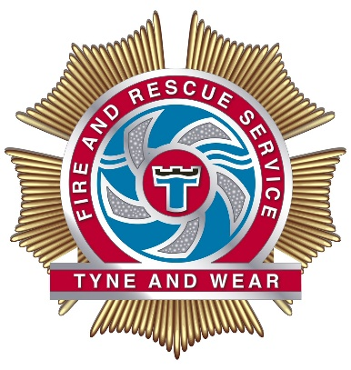
Tyne and Wear Fire and Rescue Service

Role: Group Manager B (GMB)
Salary: Development £ 47,887
Competent £ 53,086

Plus 20% Flexible Duty System allowance and essential car user allowance.
We are seeking to fill a temporary vacancy at GMB as part of our Flexi Duty Officer Cadre.
We aim to identify a small pool of candidates that will be placed in a pool for up to 12-18 months to fill any future permanent vacancies.

About Us

Tyne and Wear Fire and Rescue Service are seeking to appoint ambitious and forward-thinking individuals, to the role of Group Manager (B).

Tyne and Wear Fire and Rescue Service is a metropolitan Service that operates across the North East of England covering five local authority areas and a diverse population of around 1.1 million citizens. Operating out of 17 fire stations, the service works closely with partners and the community and has a proud record of investment in its workforce, safety and welfare. The service is investing in resources and people and our proposals in our draft 2021-2024 IRMP clearly signal the investment in front line service delivery to communities.
The Service values and respects the diversity of its employees, and aims to recruit a workforce that represents the communities we serve. We welcome applications irrespective of people’s race, disability, gender, sexual orientation, religion or belief, age, gender identity, marriage and civil partnership, pregnancy and maternity.

About the role

The role of Group Manager (B) is an integral part of the Service’s Senior Leadership Team and ensures the provision of a professional, inclusive, innovative and effective Fire and Rescue service in accordance with all statutory and legal duties. You will need to be operationally and sector competent as the role carries a responsibility to deploy to operational incidents.

Operating in the context of a Fire and Rescue Service will naturally bring challenges as well as opportunities to really make a positive difference to the lives of your colleagues and the communities that we serve. To do this it will be critical for us to see how you have demonstrated effective leadership to deliver transformational change, underpinned as a minimum with competency in Level 2 Incident Command.

Closing date for applications is 17 September 2021 at 1200 hours.
About the Selection Process

Set out below are the key dates relating to this selection process:

Stage | Timeline
Advert closes | 17 September 2021
Notification of shortlist | 22 – 24 September 2021
Assessment activities:  - i3 Profiling | 27 – 30 September 2021
Incident Command Level 3 Assessment of Potential | 04 – 08 October 2021
Onsite assessment activities:  - Employee interview panel  - Presentation  - Interview | 11 – 15 October 2021  11 – 15 October 2021  11 – 15 October 2021
Notification of selection | 20 – 22 October 2021
Please note the dates detailed may be subject to change due to COVID impact.

Interested in applying?

To request an application pack or for further information about the role please email the HR Recruitment team at: recruitment@twfire.gov.uk.
Further information about our Service can be found by visiting www.twfire.gov.uk and our various social media channels.

This is an opportunity to exercise real influence over the future of our Service and informal contact can be made to discuss this role with an Area Manager, please email: Exec.Support@twfire.gov.uk and we will get back to you with a date and time for that to happen.

Thank you and good luck!

