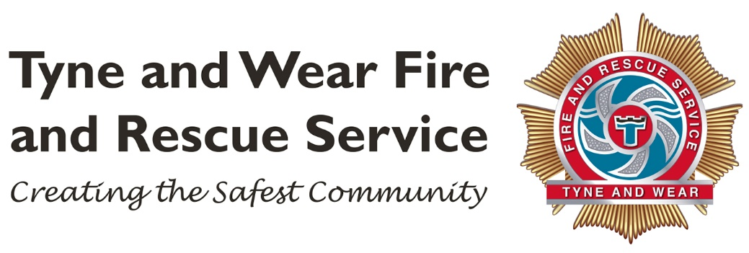

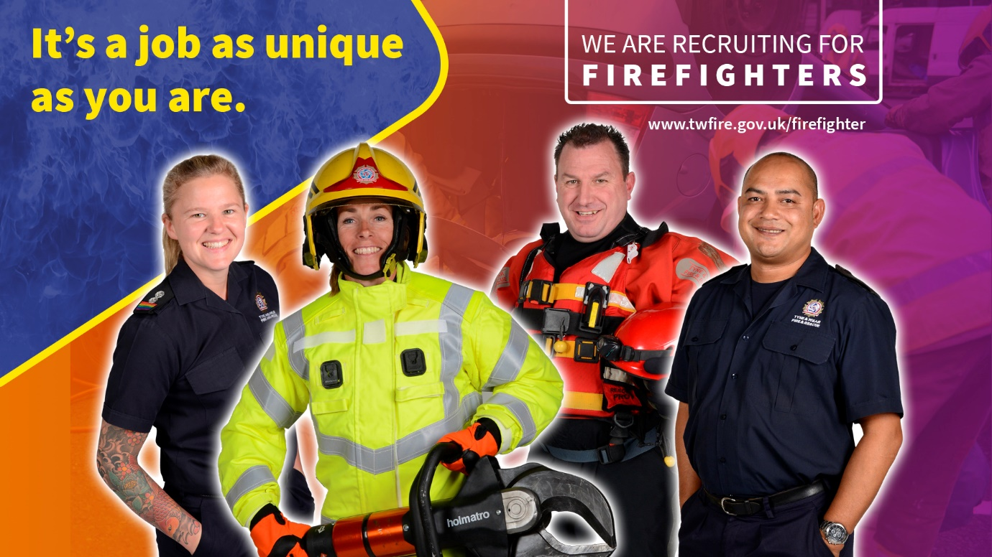

Wholetime Firefighter
Guidance for Applicants

2020

How to use this guide

This booklet is designed to help guide you through the application process.

You can read it all in one go, or refer to each section as your reach each stage of the process.

Before you submit your application, please make sure that you read Section 1:

- Eligibility – this will help you identify if your application will be accepted

- How good a match are you? – this will help you understand what the job involves and what we look for in a candidate

- The selection process (summary) – this will give you an overview of the deadlines for each stage of the process

If at any point you have a question, please check our Frequently Asked Questions (FAQs) before you contact us. The FAQs are available from page 31 of this booklet. If you do need to contact us, you can do this by emailing Recruitment@twfire.gov.uk.

If you have a disability and require reasonable adjustments to help you take part in the recruitment and selection process, please note this on the application form and we will contact you to ask what your disability is and to send us any supporting information such as a copy of your Education Health Care Plan (ECHP) or Statement.

GDPR Statement

How we use your data
- We will hold and process your data for the purpose of administrating the selection process for wholetime firefighters.
- We may use your data to ask you to participate in our evaluation surveys.
- We are committed to protecting your data and it will only be used for the purpose of recruitment.
- We will hold your data in line with our current retention schedules after which time it will be permanently deleted.
- You have the right to withdraw your consent for us to hold your data at any time. This can be done by emailing DPO@twfire.gov.uk.

Contents
Section 1 5
Eligability 5
How Good A Match Are You? 5
What Firefighters Do 7
What we look for in a candidate 7
Skills & Qualities 7
Selection Process Timeline 8
The journey to becoming a firefighter 9
Pay & Benefits 9
Hours of Work 9
Pay 9
Pension Benefits (Summary) 10
Annual leave 10
Work/Life balance 10
Section 2 11
Stage 1 Applications Process 11
When to apply 11
How to apply 11
Stage 2 Online Tests 12
Important information before you begin 12
About the tests 12
Behaviour Style Questionnaire (BSQ) - 13
Situational Judgement Test (SJT) 13
Numerical Test 13
Verbal Reasoning Test 13
Mechanical Test 13
Stage 3 Bleep Test 14
What is the Bleep Test? 14
Improve your fitness 14
Stage 4 Role Related Tests 15
What is involved? 15
Ladder Climb - 16
Ladder Lift - 16
Casualty Evacuation 16
Equipment Carry 16
Equipment Assembly 16
Enclosed Space 16
Stage 5 Competency Based Interviews and Online Test Validation 17
How to prepare for the interview 17
Online Tests Validation 17
Stage 6 Fitness and Medical 18
Fitness Test 18
What is involved in the medical? 19
Stage 7 Pre-employment Checks 20
Pre-employment checks 20
Appendix 1 21
Personal Qualities and Attributes (PQA) 21
Appendix 2 27
Firefighter Role Map 27
Appendix 3 28
Are You Ready To Be A Firefighter? Checklist 28
Appendix 4 29
Medical Standards - Eyesight 29
Appendix 5 31
Frequently Asked Questions 31

Section 1

Eligability

To apply for one of the roles, you must meet all of the eligibility criteria set out below:

- you must be aged 18 years or over on 1 April 2021
- you must have the right to work in the UK

A ‘Standard’ Disclosure and Barring Service (DBS) check is a requirement for the role. Please refer to the Frequently Asked Questions for information/advice regarding convictions.

An ability to confidently swim at least 25 meters is desirable.

How Good A Match Are You?

The journey to becoming a firefighter once you have been offered the job involves a lot of physical, practical and theoretical training.

How fit you need to be

As a guide, you are likely to have the minimum level of cardiorespiratory fitness for UK firefighting if you can:

  - Run 1.5 miles (2.4 kilometres) continuously in 12 minutes or less (this is equal to running 6 laps of a 400m outdoor athletics track in 12 minutes).
  - Run on a treadmill at 7.5mph (12 km/h) for 12 minutes.
  - Perform the multi-stage shuttle run test (bleep test) to at least level 8 shuttle 8.

You are likely to have the minimum physical strength and muscular endurance if you can:
  - Shoulder press 25 kg once in an overhead, upright seated position.

We have published a copy of a 12 week fitness programme to help build up your strength and stamina: www.twfire.gov.uk/firefighter

What Firefighters Do
The role of a firefighter is varied, challenging and rewarding.
Responding to incidents
Firefighters face all kinds of different challenges, such as fires, unpredictable environmental factors like floods and storms, road traffic collisions and unforeseen events like oil spills and the growing threat of terrorism
Keeping our communities safe

A big emphasis is placed on our role within the community, firefighters spend time out in the community raising awareness, conducting home fire safety checks and communicating fire prevention and other safety messages.

What we look for in a candidate

We look for disciplined, fit and highly motivated individuals who can work confidently with the communities that we serve and within highly pressured and unique environments.
See the Role Map on page 24 for further information about the competencies for the job.
To help you decide if this job is for you, we have developed a checklist, this can be found on page 25.

Skills & Qualities

Firefighters need a range of skills to succeed, we call these Personal Qualities and Attributes (PQAs). A list of the PQAs are on page 20. Having a good understanding of these will strengthen your application.

In addition to the PQAs, you need to be able to show us that you can safely and confidently work in stressful and risky environments.

You will also find videos that we have posted helpful in understanding the job and what it takes to succeed. These are available from our website.
https://www.twfire.gov.uk/work-for-us/our-roles/apply-to-be-a-firefighter/

Selection Process Timeline
Stage 1 Complete an online application form (including submitting a ‘supporting statement’)
26 October at 09:00hrs to 13 November at 08:59hrs

Stage 2 Complete 5 online tests
20 November at 12:00hrs to 30 November at 08:59hrs

Stage 3 Bleep Test (you must achieve at least Level 8)
14 December to 18 December

Stage 4 Role Related Tests
4 January to 22 January

Stage 5 Competency Based Interview and online tests validation
1 February to 12 February

Stage 6 Fitness & Medical
22 February to 26 February

Stage 7 Pre-employment Checks
From 1 March

- Please make a note of the deadlines, we do not offer extensions.
- You need to pass each stage to move onto the next stage.
- We do not accept CVs.

The journey to becoming a firefighter

The training is done in 2 stages:

- Phase I (Trainee) – 14 week intensive course
- Phase II (Development) – around 3 years
It takes around 3 years to become a ‘Competent’ (fully qualified) firefighter.
The training is intensive and requires a lot of personal commitment to your development and maintaining your physical fitness.
You will be on probation for the 3 years until you become competent, and we will provide you with as much support as we can.

Pay & Benefits

Hours of Work

During your first 14 weeks of joining us, you will undertake the Phase I (Trainee) course, which takes place at our Service Headquarters and you will attend Monday to Friday between 08:00 and 18:00. You will also need to so some revision and preparation in your own time for the duration of the course.

During Phase II (Development) from week 15, you will be posted to one of our Community Fire Stations, and you will join the shift system where you will work 2 day shifts (09:00 to 18:00), 2 night shifts (18:00 to 09:00) followed by 4 days off.

Pay

Stage of Development | Annual (gross) | Monthly (Gross)
Phase I (Trainee) first 14 weeks of employment | £23,833 | £1,986.06
Phase II (Development) minimum 3 years | £24,826 | £2,068.84
Competent (on completion of Phase II) | £31,767 | £2,647.25

Pension Benefits (Summary)

New entrants will be contractually enrolled on to the Firefighter Pension scheme 2015. Highlights of the pension includes:

- A pension of 1/59.7th of your pay every year, added to your pension account and protected against inflation.
- The option to convert part of your pension into a tax-free lump sum when you retire.
- Immediate payment of pension benefits to you.
- Retire at pension age – 60, or retire early from age 55 (but with an early payment reduction).
- A lump sum of three years’ final pay if you die in service.
- A substantial employer contribution towards the cost of your benefits.
- The choice of deferring payment of your pension benefits until State Pension Age if you leave the scheme early, or transferring them to another pension arrangement.
- Employee contributions vary from 10% to 14.5% of your pay depending on your rate of pay.

Annual leave

You will start on 29 days paid leave. Leave is allocated in advance, the leave year runs from 1 January to 31 December.

Please note, that we cannot approve annual leave in your first 14 weeks of employment.

Work/Life balance

We are committed to providing our staff with a range of options which support a work life balance, we do this through a number of family friendly policies.

Section 2

Stage 1 Applications Process

When to apply

You can complete your application 24 hours a day between 26 October at 09:00hrs to 13 November at 08:59hrs. We will not close the vacancy until 08:59hrs on 13 November 2020. There is no advantage to rushing to submit your application.
We expect peak times on the application system to be on the first and last date of the applications being open, so please try to avoid these times and keep trying if you experience any problems with the system.
Please note that we do not accept late applications or CVs.

How to apply

You can submit your application by completing the online application form which will be available from 26 October 2020 via our website https://www.twfire.gov.uk/work-for-us/.
The application form will not work well on a tablet or phone. You are advised to use a PC or laptop.
The application form will check if you are eligible to apply for the role. Make sure that you check your answers to the questions and your contact details before you submit as you will not be able to make any changes once you submit.
We will communicate with you using the email address you have provided. We recommend that you use a personal (rather than work/university) email address and check your spam folder for our messages.
You will be required to upload in Microsoft Word format, a ‘supporting statement’. The supporting statement is where you need to tells us, why you are suited to the job and what skills, attributes, qualities and experiences you can bring.
You will find looking at the Role Map and PQAs on pages 24 & 20 will help you submit a strong supporting statement.

Stage 2 Online Tests

For this stage you will need to complete 5 online tests. On 20 November, we will email you the 2 links needed to access the tests.
You can do the tests in any order. The tests will be available 24 hours a day, between 20 November 2020 at 12:00hrs to 30 November 2020at 08:59hrs. Please note that we do not offer extensions.
If you need any technical support, you can contact us by emailing Recruitment@twfire.gov.uk please note that we can only provide this Monday to Friday between 09:00 and 16:30 and it may take up to 2 days to respond.

Important information before you begin

You will also need to use a laptop or PC to access the tests as they do not work well on a tablet or mobile.
To complete the tests, you will need to use the following internet browsers:
- Internet Explorer 9 and above
- Firefox 4.0 and above
- Google Chrome 10.0 and above
- Safari 5 and above (Mac and PC)

Your browser should also have JavaScript and Cookies enabled. Refer to the Help function of your browser for guidance about these settings. The tests are designed to be viewed with a screen resolution of at least 1024 x 768 pixels.

About the tests

You get just one opportunity to take the tests, so make sure that you follow the guidance and advice to give yourself the best chance of passing the tests.
You must do the tests on your own (if you get to interview, we will re-test you under supervision). You must pass all of the tests to be considered for the next stage of the process. There is no right of appeal.

Behaviour Style Questionnaire (BSQ) - is designed to identify your preferred behaviours and values in a working environment.
The questionnaire assesses whether you have the right behaviours and attitudes to be effective in the role. No revision or additional study is required, although you may find it helpful to look at some examples before you complete the BSQ.
Visit https://www.twfire.gov.uk/wp-content/uploads/2019/10/Behavioural-Styles-Questionnaire.pdf for example questions.
The test is not timed so take your time to read the question and provide your answer.
Situational Judgement Test (SJT) - measures your judgement and decision -making skills in situations that are typical in the Fire and Rescue Service. No revision or additional study is required, although you may find it helpful to look at some examples before you complete the SJT.
Visit https://www.twfire.gov.uk/wp-content/uploads/2019/10/Situational-Judgement-Test.pdf for example questions.
The test is not timed so take your time to read the question and provide your answer.
Numerical Test – you will be required to calculate numerical equations that are equivalent to GCSE (level 3 or grade c) maths.
Visit https://www.assessmentday.co.uk/aptitudetests_numerical.htm for practice papers.

The test is timed with a set amount of time per question.

Verbal Reasoning Test – you will be required to answer questions on short passages of information. No prior knowledge is required.
Visit https://www.assessmentday.co.uk/aptitudetests_verbal.htm for practice papers.

The test is timed with a set amount of time per question.

Mechanical Test - you will be required to apply cognitive reasoning to mechanical, physical and practical concepts in order to solve problems.
Visit https://www.assessmentday.co.uk/mechanical-reasoning.htm for practice papers.

The test is timed with a set amount of time per question.

Stage 3 Bleep Test

All firefighters have to be physically fit to do the role. We look for candidates who have a good all round level of fitness.
As a minimum, you need to demonstrate that you can meet Level 8 shuttle 8 on the 20m bleep test. If you can run 1.5 miles in 12 minutes then you are likely to meet this standard.
We will invite the top 300 candidates who passed the online tests, to take the bleep test. The dates for the tests will be during the week of 14 December 2020.

What is the Bleep Test?

The bleep test (sometimes called the shuttle run) involves running back and forth along a 20 meter track in time to a series of beeps. The beeps during the course of the test get progressively faster as the levels increase. You are required to reach the other side of the track before the next beep.
We recommended that you practice the test prior to any fitness assessment where you are expected to meet a minimum level (Level 8.8) on the bleep test.
Further information about the bleep test and helpful apps are available from http://www.bleeptest.co.uk/thebleeptest/.
We will select the top 150 highest performing candidates to progress to the next stage of the selection process.

Improve your fitness

You should have all rounded fitness so make sure that your exercise routines are varied. Shin splits are a common problem for our new recruits, you can minimise this impact on yourself by making sure that you stretch properly before and after exercising and seeking advice from a personal trainer or physiotherapist on what those stretches are.
Also, train on different surfaces and in different footwear. Running in fire boots is very different to running in trainers!
Visit https://www.twfire.gov.uk/wp-content/uploads/2019/12/Preparatory-fitness-programme-FireFit-steering-group.pdf to download a fitness guide.

Stage 4 Role Related Tests

The Role Related Tests (RRTs) are designed to test your all round strength, stamina, dexterity and ability to safely carry out tasks by following instructions.
The tests will take place during the weeks of 4 January 2021 to 22 January 2021.
We are only able to invite 150 candidates (those who score the highest in the bleep test) to do the RRTs.
The tests are designed to assess your level of physical fitness in line with the requirements of the role. You must perform all the tests whilst wearing firefighter personal protective equipment (PPE), provided on the day. For each test, full instructions will be provided.

What is involved?

We are a disciplined uniformed service (the fire service roots are from the Navy).
We expect to see high standards of conduct and behaviour at all times. You will be observed and marked on:

- how well you follow instructions
- your motivation
- your communication skills
- your attitude and overall presentation (how you come across)
- how you treat others

You will work in groups but will be tested individually. Your behaviours will be observed throughout the time you are on our premises. The session will last about 3 hours.

There are 6 different tests, most of these are timed. A video of the tests is available from https://www.twfire.gov.uk/work-for-us/our-roles/apply-to-be-a-firefighter/.

The next page gives you a summary of what is involved.

Ladder Climb - designed to assess confidence at heights. Wearing a safety harness, you are required ascend two thirds of the way up a 13.5m ladder and secure yourself by hooking one leg through the ladder. You will be asked to lean backwards and outstretch your arms to the sides, then confirm a symbol being shown by the assessor at ground level.
Ladder Lift - designed to assess upper and lower body strength and coordination. You will raise the bar of a ladder lift simulator to the required height with 15kg of weight placed on the simulator cradle, which gives a total lift load of 25kg.
Casualty Evacuation - designed to assess upper and lower body strength and coordination. You will drag a 55kg dummy backwards around a 30m course, by a carrying handle fixed to the dummy.
Equipment Carry - designed to assess upper and lower body strength and coordination. You will carry items of equipment up and down a course between two cones placed 25m apart.
Equipment Assembly - designed to assess manual dexterity. You are given a demonstration of the test before having to assemble and disassemble a number of components to make an item of equipment.
Enclosed Space - designed to assess confidence, agility and stamina. You will put on a facemask and with un-obscured vision make your way through a crawl and walkway. Once inside the crawl/walkway you will have your vision obscured and return to the start.

Stage 5 Competency Based Interviews and Online Test Validation

The interview stage will take place in the weeks of 1 February 2021 to 12 February 2021.
We aim to invite up to 80 candidates to an interview.
The interview will have 2 panel members. The questions they ask will be based on the PQAs (see page 20).

How to prepare for the interview

Make sure that you have read and understood what the PQAs are.
Re-read your supporting statement that you sent with your application.
Think of real life examples from your work, education, volunteering or personal life that will show how you meet each of the PQA competencies.
Make sure you use a structured approach, for example STARE which stands for:
- Situation – set the scene, what was the situation?
- Task – what was your responsibility? / What did you need to do?
- Activity – what actions did you take? / How did you respond to the issue?
- Result – what happened? / What was the outcome?
- Evaluation – what did you learn from the experience?
Practice your answers.
There is a lot of information on how to prepare for a competency based interview. Try searching for these up on the internet.
Remember that we are a disciplined uniformed service, so we expect you to present yourself in a professional way and demonstrate high standards of behaviours and appearance.

Online Tests Validation

When you attend your interview, you will be required to sit further online numerical, verbal reasoning and mechanical tests under our supervision. This is so that we can be assured that it was you who did the tests in Stage 2 of the selection process.

Stage 6 Fitness and Medical

We will take up to 40 candidates to the fitness and medical stage, the dates will be 22 February 2021 to 26 February 2021.
The fitness and medical assessments will take place at the same time, you can expect to be with us for about 2.5 hours.

Fitness Test

You will need to do the Chester Walk Test. This involves a progressive incline walk test which is done on a treadmill.
It is designed to test your aerobic capacity.
Fitness Level Required
As a guide, you should have the minimum level of cardiorespiratory fitness for UK firefighting if you can:

  - Run 1.5 miles (2.4 kilometres) continuously in 12 minutes or less (this is equal to running 6 laps of a 400m outdoor athletics track in 12 minutes).
  - Run on a treadmill at 7.5mph (12 km/h) for 12 minutes.
  - Perform the multi-stage shuttle run test (bleep test) to at least level 8 shuttle 8.

You are likely to have the minimum physical strength and muscular endurance if you can:
  - Shoulder press 25 kg once in an overhead, upright seated position.

We have published a copy of a 12 week fitness programme to help build up your strength and stamina: www.twfire.gov.uk/firefighter.

What is involved in the medical?

You will need to take a full medical assessment, carried out by our occupational health provider.
Before attending your medical, you should obtain a list of your vaccinations from your GP.
If you have any concerns about meeting the eyesight standards, you are advised to seek advice from qualified optician. Information about the National Standards for Eyesight can be found on page 26.
You will be asked to complete a questionnaire about your medical history and you will need to do the following tests:
- Hearing
- Lung function
- Eyes
- Grip strength
- Blood pressure
- General tests based on your completed medical questionnaire
- Drug and alcohol

We will invite more candidates to the fitness and medical stage than we have jobs on offer. This is because sometimes, we need to contact the candidates G.P. or Specialist for further information before we can decide if they are fit for the role. This can cause delays and we may not get your medical sign off in enough time to offer you a job.
We also aim to have a small number of candidates in reserve, in case one of the people who we offer a job to, is withdrawn from the process.
No-one should assume that an invitation to the fitness and medical stage is a guarantee that you will be offered a job.

Stage 7 Pre-employment Checks

All of our offers of employment are conditional on successfully completing the pre-employment checks.

Pre-employment checks

These checks are done after you have been sent a conditional offer of a job. We check:

- your right to work in the United Kingdom
- your identity
- your references
- Standard DBS Check

If any part of your pre-employment checks do not meet the required standards, we will be unable to confirm your appointment and any offer will be withdrawn without notice.

The course is planned for early April 2021. You will not be allowed to take any holiday during the Phase I training.

Good luck with you application and thank you for considering a career with Tyne and Wear Fire and Rescue Service.

Appendix 1

Personal Qualities and Attributes (PQA)

There are 9 PQAs that all UK firefighters have to be able to demonstrate. These are set out below and will help you when writing your supporting statement and to prepare for your interview.

Commitment to Diversity and Integrity – understands and respects diversity and adopts a fair and ethical approach in all situations
- Is concerned to treat people fairly and ethically (e.g. completes work according to same high standards regardless of individual differences)
- Recognises the importance of an awareness of the community and understands its needs (e.g. is aware and respectful of differing cultures and backgrounds)
- Recognises and has respect for others’ backgrounds, views, values and beliefs (including religious beliefs)
- Maintains an open approach with others, taking account of, and accepting, individual differences such as age, ethnicity, gender, religious beliefs, social background, disability, sexual orientation and physical appearance
- Is committed to the Fire and Rescue Service values and actively promotes them (e.g. challenges inappropriate behaviour)
- Is honest when working with others and accepts accountability for own actions (e.g. takes responsibility for own mistakes; respects the need for confidentiality (is trusted to enter others’ homes)
- Proactively challenges unacceptable behaviour inconsistent with Fire and Rescue Service values, stating own and organisation’s position clearly (e.g. when over-hearing a colleague use inappropriate language)

Openness to Change – is open to change and actively seeks to support it
- Demonstrates an understanding of the need for change within the Fire and Rescue Service (e.g. explains the reasons for new working practices to colleagues absent from briefings)
- Aware of the impact of changes to the Fire and Rescue Service on their role (e.g. understands changes to working practices)
- Accepts change both within the Fire and Rescue Service and in their own role (e.g. willingly participates in Community Fire Safety activities)
- Identifies ways, both within the Fire and Rescue Service and the local community, of supporting change and takes action where possible (e.g. volunteers to learn new tasks or ways of working)
Confidence and Resilience – maintains a confident and resilient attitude in highly challenging situations
- Remains in control of own emotions during emergency situations (e.g. does not panic and considers risk)
- Concentrates on the task despite pressure (e.g. pressure of time, noise, conflicting information and tasks, and concern for casualties)
- Challenges or questions others constructively to achieve more effective outcomes
- Retains confidence in own ability or convictions despite setbacks (e.g. after a Community Fire Safety talk is received poorly)

Working with Others – works effectively with others both within the Fire and Rescue Service and in the community
- Works effectively with all team-members according to defined role (e.g. in teams of 2 and up to teams of 20), adjusting his/her role in accordance with instructions and changing circumstances
- Proactively generates positive working relationships both internally (e.g. attempts to get to know everyone in working environment) and externally (e.g. liaises with community groups to promote fire safety; works well with other emergency services)
- Concerned about the wider team and is aware of shared objectives, as well as those of his/her immediate work-team (e.g. willing to give Community Fire Safety talks at schools)
- Is sensitive to the feelings and well-being of others and takes action to support them (e.g. able to reassure and calm members of the public in emergency situations; reminds colleague to check air when using breathing apparatus)
- Is able to present an approachable and positive image of self and the Fire and Rescue Service to everybody in the community, irrespective of individual differences (e.g. age, ethnicity, gender)

Situational Awareness – maintains an active awareness of the environment to promote safe and effective working
- Constantly checks the environment and takes action to ensure safe working (e.g. looks for threats to safety of self and others)
- Has awareness of a range of safety related information without becoming unduly focused on any one piece of information
- Provides timely information to confirm progress and outcomes against objectives (e.g. keeps team informed at incidents of changing circumstances)
- Able to judge space and distance within three dimensions and time to perform tasks safely and effectively (e.g. able to judge space and distance to erect ladders.)

Effective Communication – communicates effectively both orally and in writing
- Communicates verbal messages clearly, concisely and at a level appropriate to the audience so that message is understood regardless of individual differences
- Is sensitive to the needs of the audience and tailors communication in response to feedback (e.g. able to convey the importance of fire safety without distressing members of the public unnecessarily)
- Demonstrates that they are listening to others to convey interest (e.g. by nodding and using other appropriate body language, or by asking questions) and maintains awareness for messages
- Checks understanding to ensure all messages received and sent are understood correctly
- Is comfortable communicating with both small (e.g. 2 people) and large groups (e.g. up to 30 people)
- Presents messages (e.g. fire safety information) in a way that promotes understanding (e.g. uses slides, videos and other visual aids appropriately during presentations and fire safety visits; engages with the audience)
- Able to write clear, basic and appropriate information or messages that are understood by the recipient (e.g. to complete standard Fire and Rescue Service forms and to use the BA operation entry board)

Commitment to Development – committed to and able to develop self and others
- Proactively reviews own performance using a variety of sources including seeking feedback from others
- Identifies development needs in own knowledge, skills and understanding and takes action to improve (e.g. seeks to identify and learn new methods from colleagues; recognise that own fitness levels need to be improved)
- Learns from a wide range of situations experienced by self or others (e.g. increases understanding about a community group following a safety discussion)
- Able to learn a large amount of job relevant information delivered both verbally and in writing, as part of initial training course and other development (e.g. operating procedures and standards)
- Actively encourages and supports others to improve their proficiency (e.g. updates colleagues concerning new information; shares own experiences)

Problem Solving – understands, recalls, applies and adapts relevant information in an organised, safe and systematic way
- Able to recall and apply correct, relevant job related information and procedures during incidents (e.g. training procedures for ladder erection)
- Able to adapt and apply standard or existing procedures and practices and personal skills to take account of a changing environment and to minimise risk
- Generates more than one solution to a problem and evaluates which one is best (e.g. in deciding how best to promote community fire safety)
- Considers immediate and wider objectives and implications (e.g. health and safety) to plan ahead to complete tasks in most efficient and safe way
- Prioritises, plans and completes tasks in a logical and systematic manner despite conflicting information (e.g. able to manage own actions during emergency situations)
- Able to interpret basic numerical information (e.g. in dials, tables, charts) and use basic arithmetical calculations correctly (i.e. addition, subtraction, division and multiplication) to apply task procedures (e.g. able to work out operation times when using BA equipment)

Commitment to Excellence – Adopts a conscientious and proactive approach to work to achieve and maintain excellent standards
- Continually looks to improve standards of working and offers suggestions as necessary (e.g. provides feedback concerning new or existing work practices to influence change or improve service delivery)
- Approaches work proactively and efficiently both with routine tasks and during incidents
- Adopts a conscientious approach to work (e.g. checks work to ensure all tasks completed correctly and with due attention to detail; maintains levels of personal fitness)
- Completes work according to correct procedures (e.g. refrains from taking unsafe short-cuts)
- Completes work as instructed without being checked constantly
- Is clear about the role of the firefighter and operates within agreed levels of authority, within a disciplined environment (e.g. does not take action outside own level of control without seeking confirmation)

Appendix 2

Firefighter Role Map

The Role Map is used by all fire and rescue services, it tells you about the job and links to the PQAs.

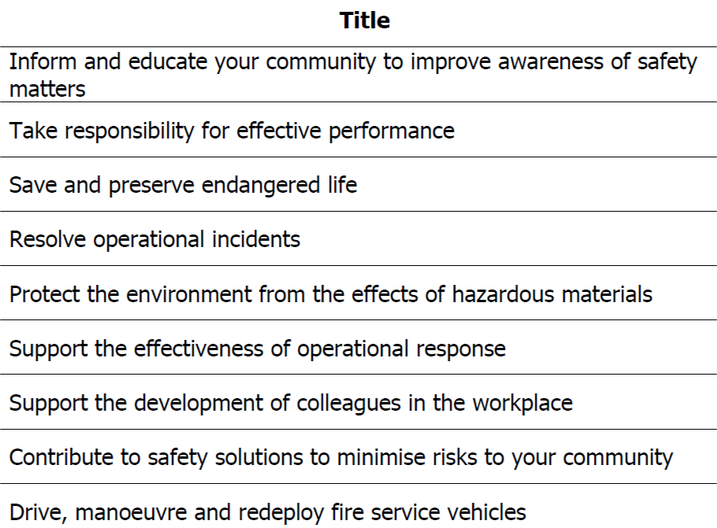

Appendix 3

Are You Ready To Be A Firefighter? Checklist
The following list of questions has been designed to help you decide whether being a firefighter is really for you. Simply tick Yes or No to each of the following questions.

 | Yes | No
Are you interested in people?
Can you get on with people from different backgrounds and cultures?
Do you want to work as part of a close-knit team?
Can you work under pressure?
Can you think on your feet and solve problems when you know a lot depends on your suggestion?
Do you have the sensitivity to deal with members of the public when they are distressed, confused or being obstructive?
Can you take responsibility for representing the Service when you are at work and when you are not?
Are you committed to always maintaining and developing your skills?
Are you committed to maintaining your health and physical fitness?
Are you prepared to work in situations where you may see blood, seriously injured or dead people?
Are you prepared to talk to people in the local community about fire safety?

Are you a practical person who likes to work with your hands/equipment?
Do you enjoy making things or finding out how things work?
Are you someone who can always be relied on to be somewhere on time?
Are you prepared to work at height?
Are you prepared to work outside in all types of weather, when it is wet and cold?
Are you prepared to work unsociable hours?
Are you prepared to work in enclosed spaces?
Are you prepared to carry heavy equipment?

If you answered ‘Yes’ to ALL of the above, and you think that you have what it takes to protect the community you live and work in, read the information provided and join our recruitment campaign.

Appendix 4

Medical Standards - Eyesight

As we get older our eyesight deteriorates. Firefighters require a certain level of eyesight to enable them to carry out their role. With this natural deterioration, it stands to reason that firefighters must meet a required standard of vision when applying to join the fire service as firefighters.

If you have any doubts regarding your eyesight we suggest that you book an appointment with your optician and take the information below to ask his/her opinion.

Colour blindness
Candidates who believe they have colour blindness may wish to be formally assessed prior to submitting an application form. The minimum standard accepted is the Farnsworth D-15 standard test. We also conduct functional tests as part of the medical process if candidates display difficulties with colour perception. Candidates must also pass the Ishihara test.

The vision standards for eyesight are:

Visual acuity

Use of aids to vision should be possible at the recruitment stage

Corrected visual acuity should be 6/9 binocularly, and a minimum of 6/12 in the worse eye

The minimum uncorrected vision for recruits should be 6/18 in the better eye and 6/24 in the worse eye for both full time and retained firefighters. The current 6/60 unaided limit should be retained for serving firefighters:

- An upper hypermetropic limit of +3.00
- Testing for myopic corrections is no longer required
- VA testing protocols must be better defined (e.g. for Snellen, distances, ambient lighting and use)
- Vision must be binocular
- Be able to read N12 at 30cm unaided with both eyes open (applicants aged 25 and over)
- Be able to read N6 at 30cm unaided with both eyes open (applicants under 25 years of age)

Visual fields
Normal binocular field of vision is required.

Eye disease
You should have no history of night blindness or any ocular disease that is likely to progress and result in future failure of the visual standards for firefighters

Individuals with keratoconus are unlikely to be fit for firefighting duties

Compound astigmatism assess for capability, history of headaches and eyestrain

Refractive surgery
Successful Photorefractive Keratectomy (PRK), laser assisted in-situ keratomileusis (LASIK), Laser Epithelial Keratomileusis (LASEK) and EpiLASIK treatments should be allowable if post-operative visual tests are satisfied

RK (radial Keratotomy) and astigmatic keratotomy are NOT suitable due increased risk of rupture and fluctuation in vision

Intraocular Refractive Surgery – used for high myopes. Therefore there are still risk of complications

Wavefront Guided Laser Refractive Surgery – since a Wavefront treatment aims to reduce aberrations, in theory it should produce better outcomes for night vision and vision in difficult low lighting levels or reduced contrast as might be encountered in a smoke-filled room; this technology could therefore have great relevance for firefighters – research is still underway to aid our understanding of this relatively new technology

Assessment after Refractive Surgery – an examination to consider the suitability of a refractive surgery patient for operational firefighting should include:

A slit lamp examination to confirm that the eye has returned to normal and that there is no significant loss of corneal transparency over the pupil area.

Refraction, topographic examination and pachymetry to screen for keratectasia.

Candidates should have their visual performance assessed using a technique sensitive to the presence of scattered light and aberrations.

Candidates should not be considered until at least 12 months post-surgery and when all medication has ceased.

Appendix 5

Frequently Asked Questions

Application and eligibility

1. Why can’t I access the online application form?

We are expecting high volumes of applicants, during peak hours (i.e. within a few hours of registration opening and closing), so the website may be slow. You will have a better experience of the system if you do not access it during peak times.

Make sure that you are using a laptop or PC. The application form does not work well on a mobile device such as a tablet or mobile phone.

2. I have completed the form but why will it not let me save my answers?

There may 2 common reasons. Either you have not provided 2 different referee details, or, you have not completed a section on the form. Use the Section Summary table to see what section is incomplete.

3. Is there a limit to the number of applications you are taking?

No, there is no limit to how many applications we will accept. We will consider all of those who have completed the Registration within the published deadlines.

4. I have a disability, how do I request reasonable adjustments?

On the application form, you will be asked to declare any disability and we will use this information to consider what reasonable adjustments you may require. We may ask you for further information/supporting evidence.

5. I won’t be 18 years old or older on 1 April 2021 but will be soon after, can I still
apply?

No. There is a legal requirement for of those who are given a job to be 18 years old.

6. I do not live in Tyne and Wear, can I still apply?

Yes. We do not have any post code restrictions for applicants. However, if you are offered a role, you will need to ensure that you have access to accommodation within a reasonable daily commute distance.

7. I have missed the deadline can I have an extension?

Unfortunately no. This campaign is strictly timetabled, which is why we pre-publish the dates of each stage.

8. I do not yet have a full UK driving licence, can I still apply?

Yes, however you must be willing to take the appropriate steps to holding a full UK driving licence. We have anticipated a business need for qualified drivers who can drive our Service Vehicles.

9. I have driving offences, do I need to declare these?

You must tell us if your licence is endorsed. You will be asked to provide details about the nature of the offence, offence code (e.g. CD10 driving without due care and attention) and also give details of the penalty (e.g. £ fine and number of penalty points). If you had to attend court you will need to give details of the outcome.

10. I have unspent convictions, do I need to declare these?

Yes, you are required to declare any offence for which the conviction is not yet spent.

Within the meaning of the Rehabilitation of Offenders Act 1974 – incorporating the Rehabilitations of Offenders Act (exemptions) 1975 and the Rehabilitation of Offenders Act 1974 (exemptions) (Amendment) Order 1996 – you are advised to declare any charge that is pending as a subsequent conviction could lead to your dismissal from the Service.

Broadly, the Act provides for anyone who has ever been convicted of a criminal offence and not sentenced to more than 2.5 years in prison to become a ‘rehabilitated person’ at the end of the rehabilitation period, provided there have been no further convictions.

At the end of this period, the conviction is considered spent and should be treated as it had never happened. Generally speaking, there are fixed rehabilitation periods for specific offences. If you are unsure whether you have to declare a previous conviction you should contact your local Probation Office, Citizens Advice or your Solicitor. Alternatively, you can consult the Home Office publication ‘A Guide to the Rehabilitation of Offenders Act 1974’.

A Disclosure and Barring Service (DBS) check will be carried out at ‘standard level’ for those who are offered employment.

11. I have made a mistake on my application form, can I make changes?

You are unable to make changes once you have submitted the applications. Unfortunately, we are unable to make any changes on your behalf either.

12. There is a problem with the system, who do I contact?

You can contact us by emailing Recruitment@twfire.gov.uk

Please note that we will respond to you as quickly as we can, however, help and advice are only available during our normal office hours: 09:00 – 17:00 Monday to Friday (excluding bank holidays).

Online tests

13. What happens if I lose internet connection whilst completing the tests?

An interrupted internet session will not affect your scores, as your responses are recorded during your session as you enter them. This information is auto saved so that when you log back in you can continue from where you left off.

14. Is the scoring system reliable?

Yes, the scoring system is very reliable. When you submit your responses, these are scored automatically by computer against a pre-determined scoring key which is applied to all applicants in exactly the same way.

15. Can I see my test results?

We do appreciate that you may want to know more details about your results, but we are unable to give out any additional information because we need to maintain the security of the scoring process. This is to ensure that all applicants are treated fairly in future recruitment campaigns.

While we understand this may be frustrating for you, we hope you can understand the importance of ensuring a fair process for all.

16. Why is my score so low?

It’s helpful for you to understand how scoring is applied to your responses to generate the final result you get. The score you are given is a ‘percentile’ score not a ‘percentage’ score and is different to what you might be used to when completing tests. Knowing the difference between the two types will help you appreciate how you scored.

A percentile score is a score generated by comparing the results of your responses to a group of individuals who have also completed the test. This group is called a comparison group or norm group. Percentile scores show your results in relation to how you performed in comparison to this norm group. For example, if you have a percentile score of 60, then this means that your score is better than 60% of people in that norm group. It does not mean that you have answered 60% of the questions correctly.

17. I have missed the deadline can I have an extension?

Unfortunately no. This campaign is strictly timetabled, which is why we pre-publish the dates of each stage.

18. I completed the test on my mobile phone or tablet and the system crashed, can I
retake the tests?

No. You are advised not to use a mobile phone or tablet to complete the tests, so it is your own responsibility to ensure the correct browser is used.

19. Will there be a Pool for candidates who pass the tests but are not offered a
chance to progress to the next stage?

No. For this round of recruitment we will not be placing candidates in a Talent Pool. If you are not invited to the next stage of the process, then that is point when your application ends.

20. Why do I need to sit another online test when I come for my interview?
We have this process in place because we need some assurance that when you took the test at Stage 2, your answers were all your own. The validation tests at the interview stage will be done at our Headquarters and you will be supervised,

